Contents

Machine Learning: 2

Deep Learning 4

Supervised Learning (both ML and DL) 7

Regression: 7

Classification: 7

Unsupervised learning. 8

Clustering 8

Dimensionality reduction 9

Reinforcement learning 10

Course: Next Steps 10

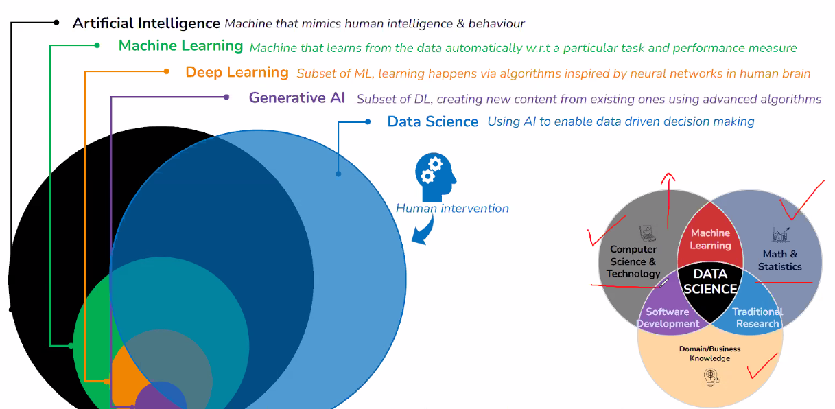

[Anuj17@gmail.com](mailto:Anuj17@gmail.com)

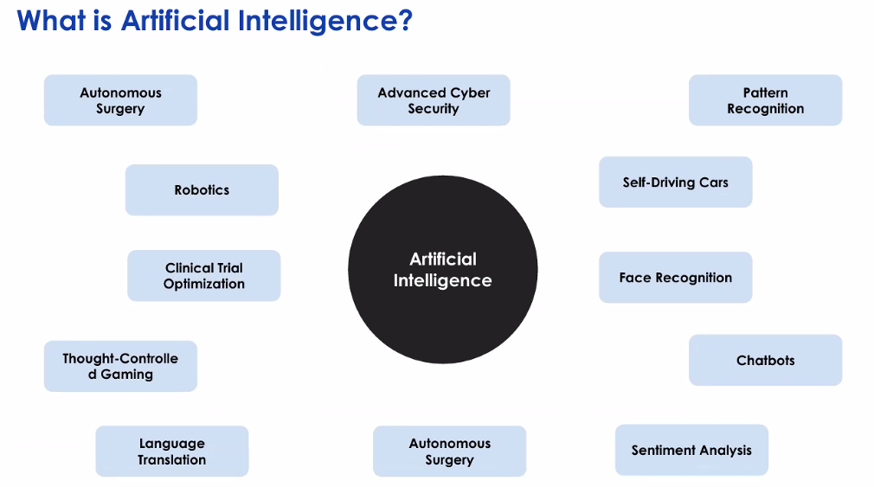

Machine Learning: Learn the patterns in data using Mathematical steps

Structured data or Labeled data (Yes or NO show up for class)

You can broadly classify as either a Prediction problem or a Classification problem.

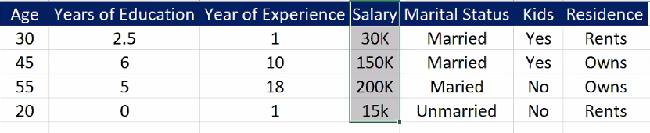

**Example for Predictive** : Predict the salary of a person

**Example for Classification**: Married or Unmarried

**Deep Learning:**

Complex data, non-structured data. Nonlinear tasks NLP tasks – DEEP learning

**Examples**: Sentiment about political problem, Image classification, self-driven cars.

Generative AI

Multi Model – Txt, video, image,

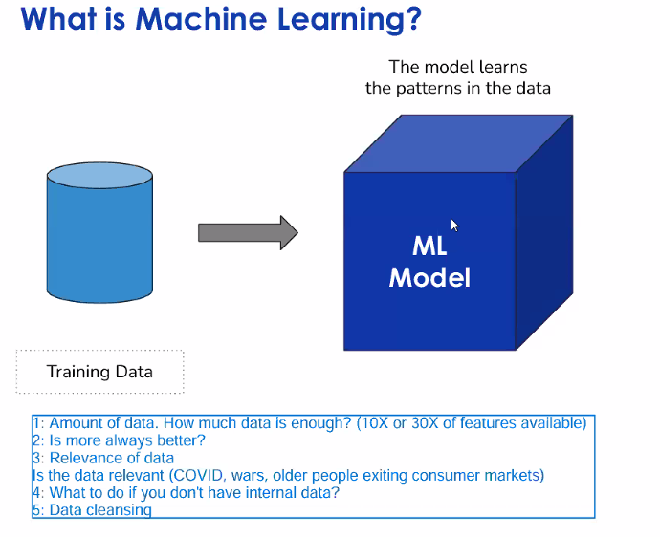

External data (something companies)

Data Cleansing / wrangling

**Predictive performance** of the model – accuracy

Recall/precision- higher the false positive / false negative.

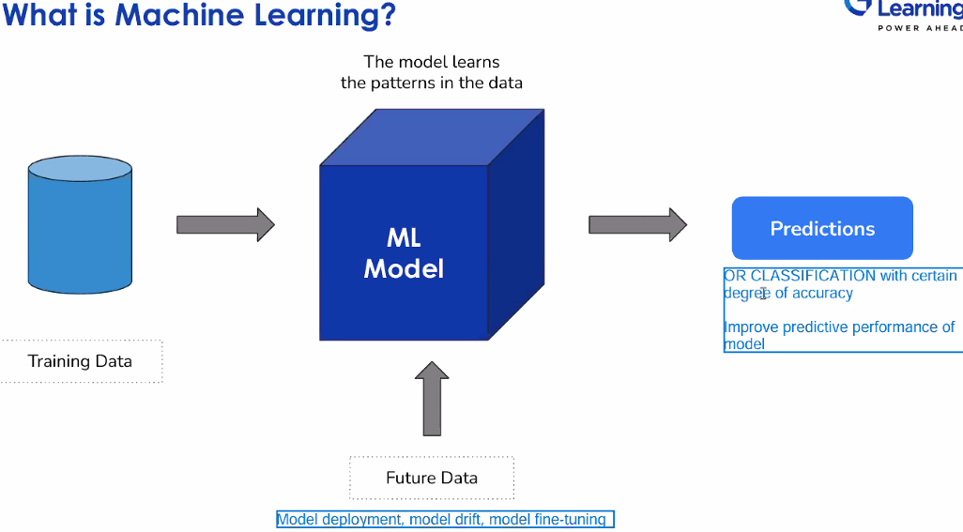

**Model drift**: How much drift is acceptable to you. How much drift 3%

Monitor the model and fine tuning the model hyper parameters.

Models have a shelf life.

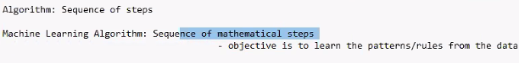Experimentation with Algorithms

Algo1🡪 50%

Algo 2 -> 60%

Algo 3 -> 90%

Accuracy and performance % Compare the performance. Use the highest %

Deep Learning: Same as above but differences with M/ L

Algorithms are using Neural networks. Birds fly Airplane design, Fish swimming.

Artificial neuron: Artificial neural networks.

2.Applications on data: Structured data (Excel, table) or Unstructured data (images, txt)

Deep learning is much more suited for Unstructured data.

3. Much **more complex – More computation**, capacity, hardware resources, **more costly**

**Explainability** [ML > DL] Black box models.

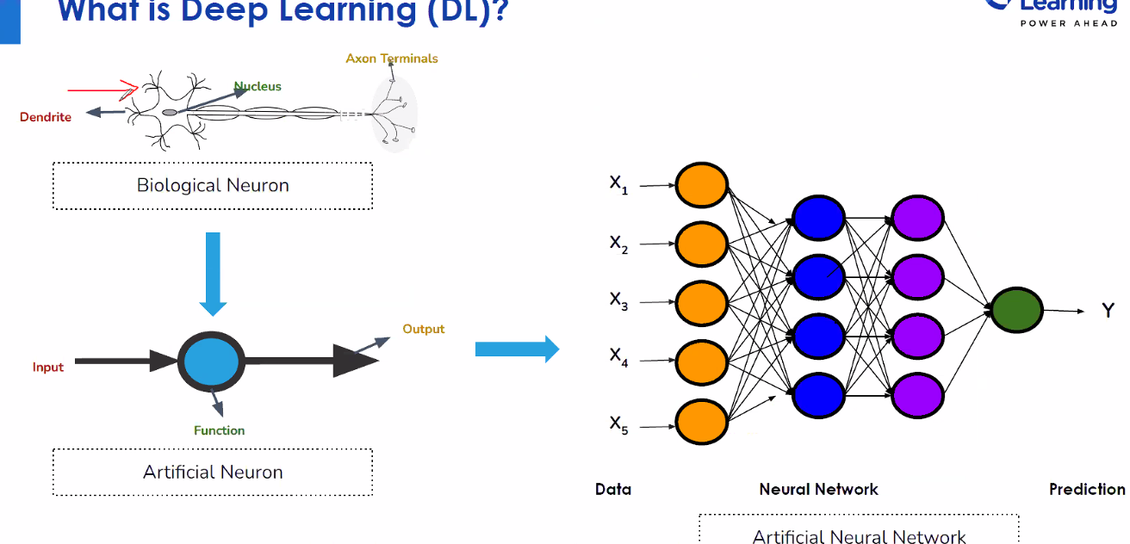

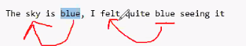

The color dots are processes and input/output of each connect and provides a desired output

Numerical weights assigned to the blue boxes weights get initiated. Activation function Purple

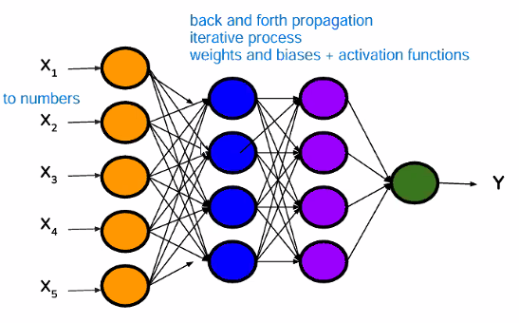



Difference between an algorithm and Model

Difference types of Learning Techniques Supervised Learning, Un Supervised Learning, etc.

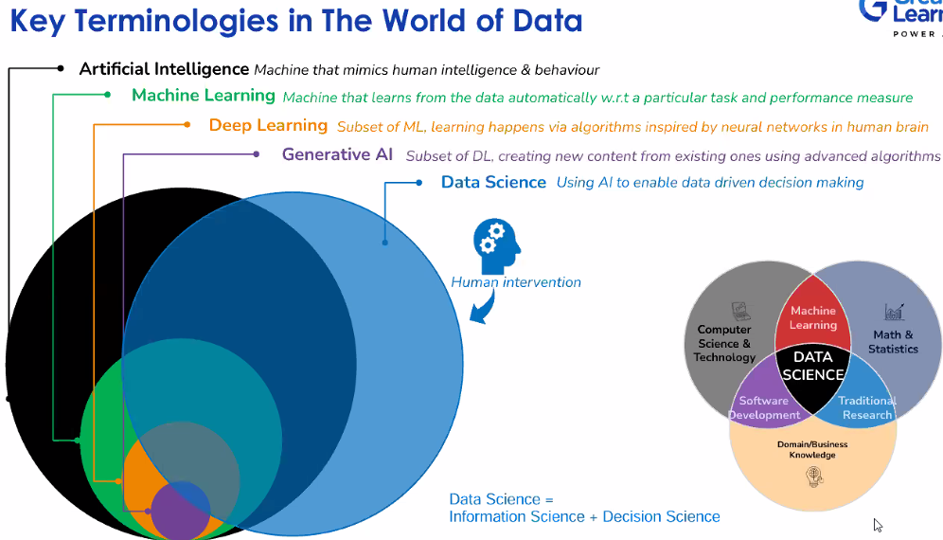

**Decision science + Information Science = Data Science**

## Supervised Learning (both ML and DL)

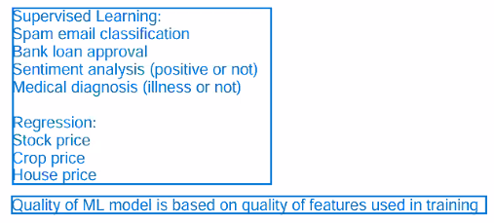

Misclassification – can happen.

### Regression:

#### Example: Real Estate buy home for new resident of DFW

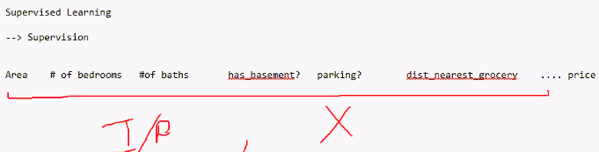

Y= Price of the house.

X is also called as independent variable and Y is dependent variable.

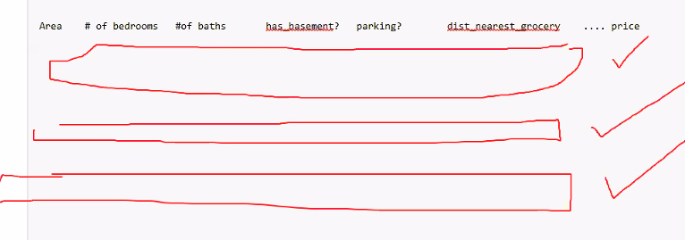

Patterns are created and u have a model, this is supervised learning – Y telling the price.

If u have X and Y continuous numbers. we **use Regression where Y numeric** value is predicted.

X can be called as feature and Y is the label.Y can be non-numeric,

### Classification:

#### Example 2: You have 1000 images and have to label them

You open each image and label is cat, dog etc. you create the y variable here Dog, cat, or Will an output if it will churn or not churn etc. - **Classification**

Sometimes we cannot say what the Y will be, only X available is provided.

## Unsupervised learning.

Not labeled data, Siff data for clusters analysis. Married and No kids, Ppl taking constant vacations

### Clustering

#### Example 3 Coffee business:

Absence of supervision

Customer # no of visits, # $ spent Fav drink Fav food Age gender | Feedback (

C1-

C2-

C3 -

Scan the QR code, capture the above information - Loyalty APP

**Clustering** – Group my data points to together and find why are they are similar to each other.

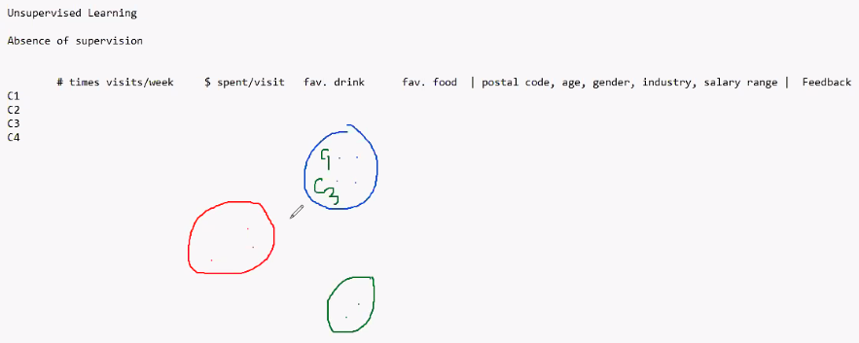

Patterns, to CREATE Y variable

Frequent visitors, Frequent buyers of a product – Loyal bucket (c1)

Customers only buy when discounts apply - C2 bucket

Bu alternate products to these customers – C3 bucket ... coffee try bagel etc.

Cluster analysis : Vendor name pump and not product

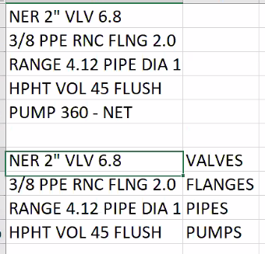

### Dimensionality reduction

Dimensions /Features/ X variables

Train a model too much of information so reduce the number of X columns by compressing them using algorithms -Dimensionality reduction

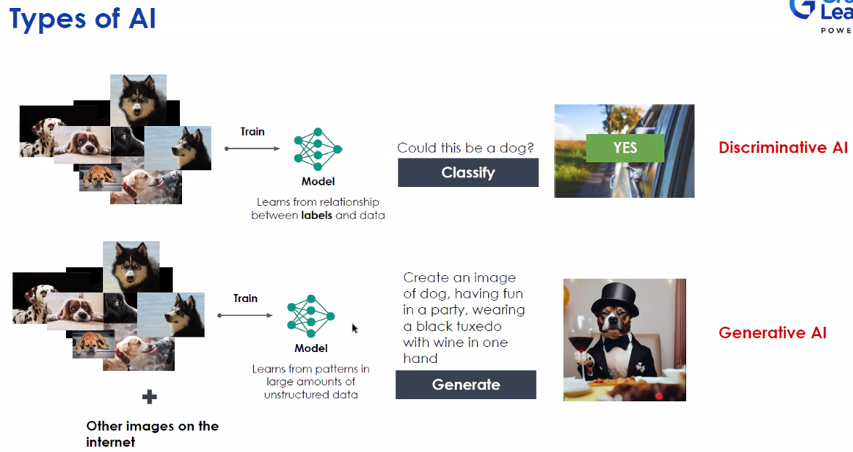

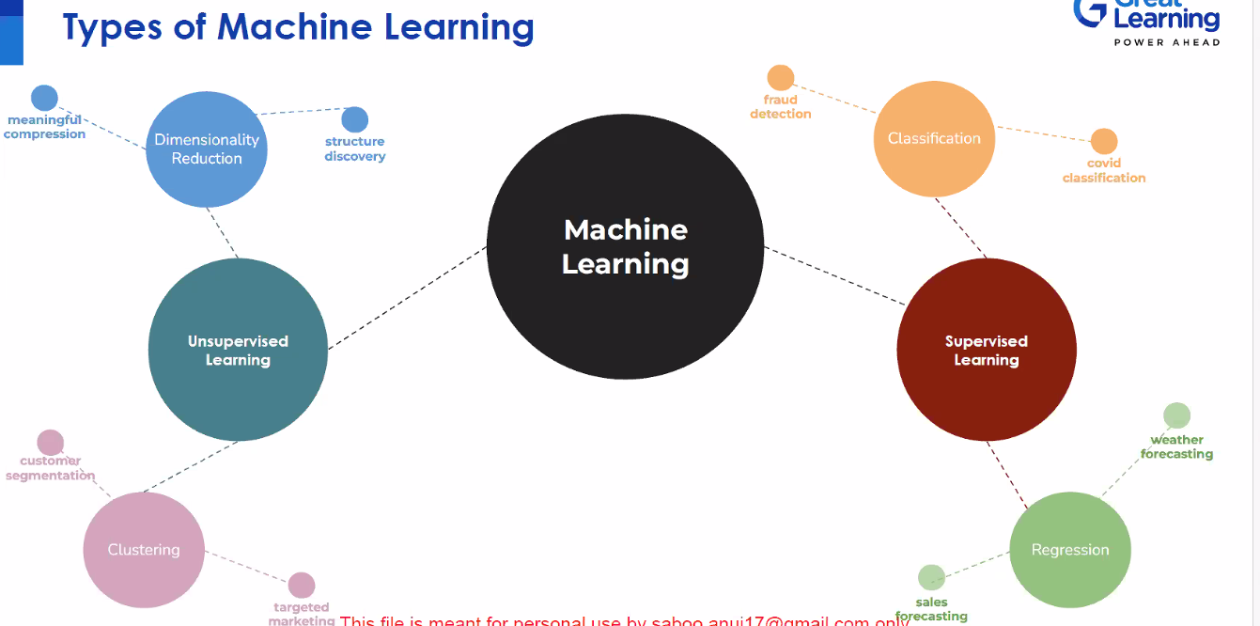

Reinforcement learning: Robots / gaming

Watch social media – Recommendation Engine learning

**State**: Last watched, likeness, battery, browser, time of the day

**Policy**: Input from the state and gives a recommendation is the policy

**Recommendation**: provided

**Feedback** Positive or negative

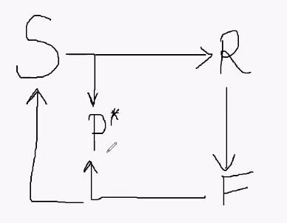

Mean squared error, means absolute error, root mean squared error, R2, Adjusted R squared - SL Regression

Recall, Precision, F1 score – Supervised Learning Classification



The prompts front end prompts and backend prompts.

Backend prompts:

* Avoid reaching out to web
* Search thru the knowledge base
* Policy changes , look thru our policy

## Course: Next Steps

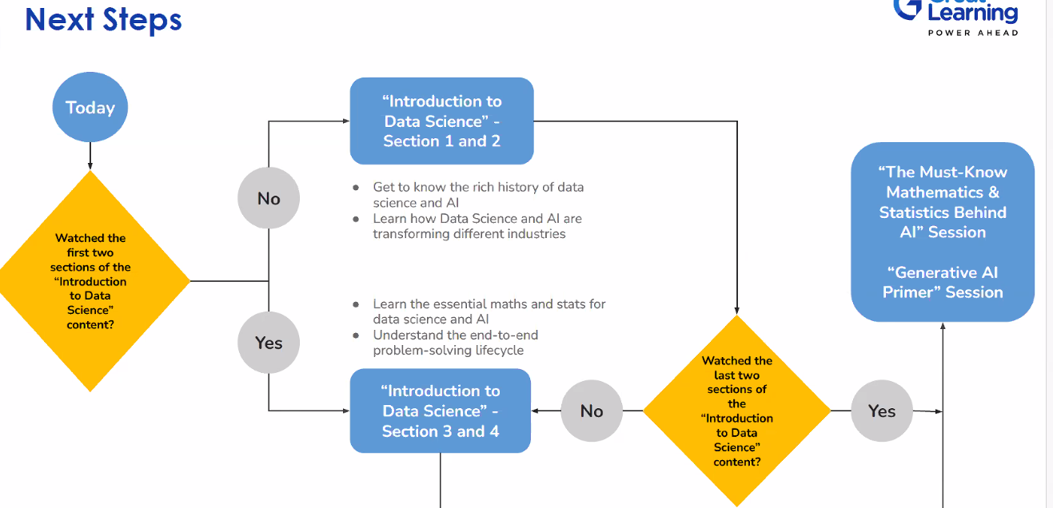

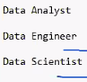futuristic, prediction

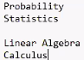

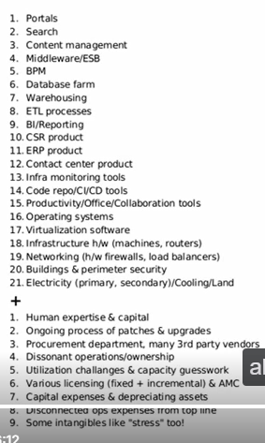

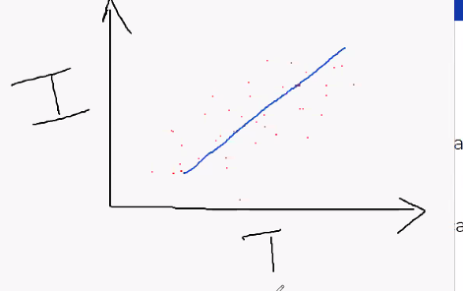Icre cream Sale / Temperature – Blue line is the Model

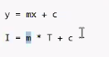 M slope or coefficient of Temperate.

C is where the line intersects the y axis (x=0)

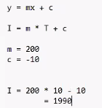

Linear Algebra and Calculus - Abstracted and details hidden with the function call.

Probability and Statistics –

**Probability:**

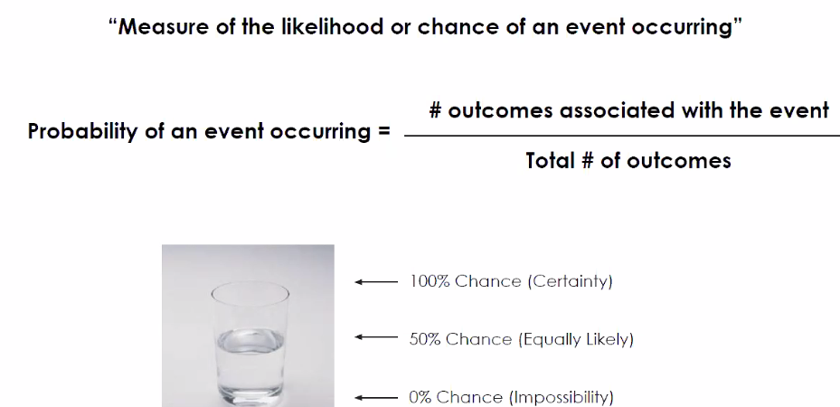

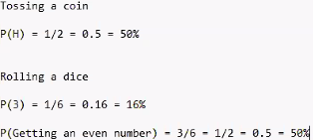

Two properties:

Probability is a number between 0 to 1 or 0% to 100%

Probability will sum to 1 or 100%

Image processed by a model to tell if its Cat, dog, of tiger

Prob of image cat, dog and tiger

Only predict the probabilities.

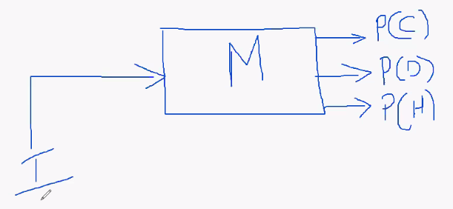

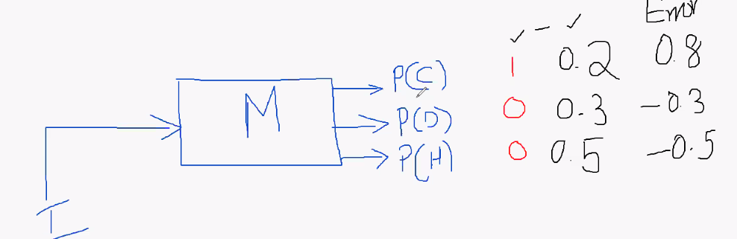

Image classification model: o/p is probability of it being cat,dog,tiger

ChatGPT, Predict the next word, and randomization as well.

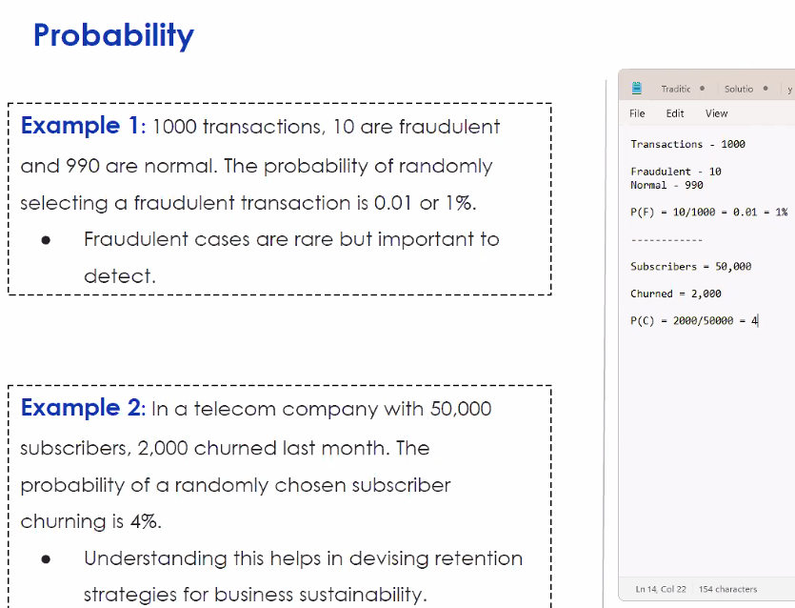

What is the probability that I will water my lawn today – Independent use cases

What is the probability of watering my lawn given that is raining outside – Dependent event ( conditional Probability).

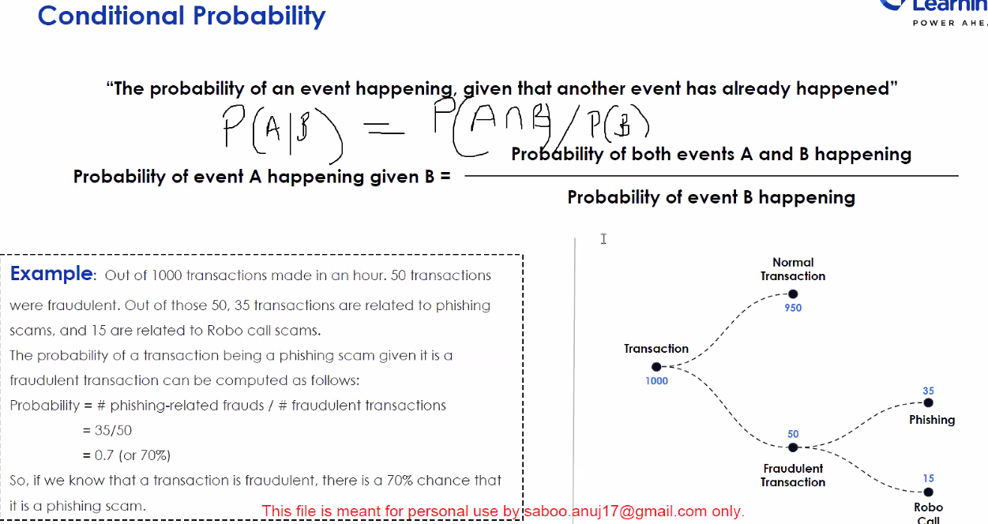

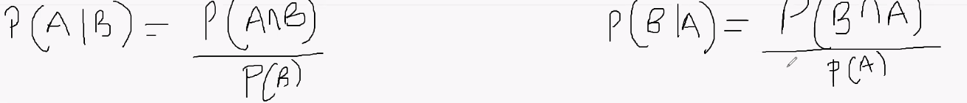

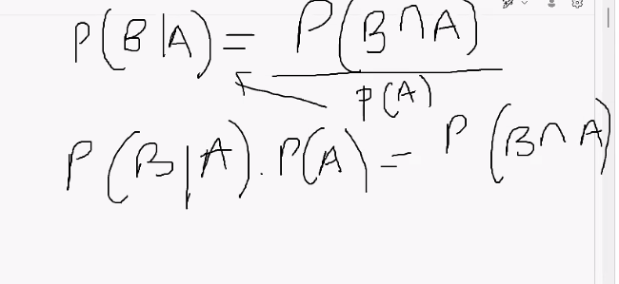

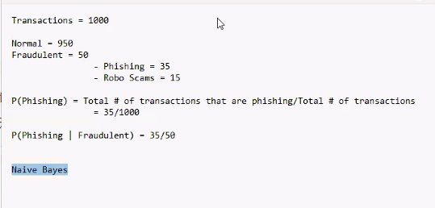

Probability is for classification Problem.

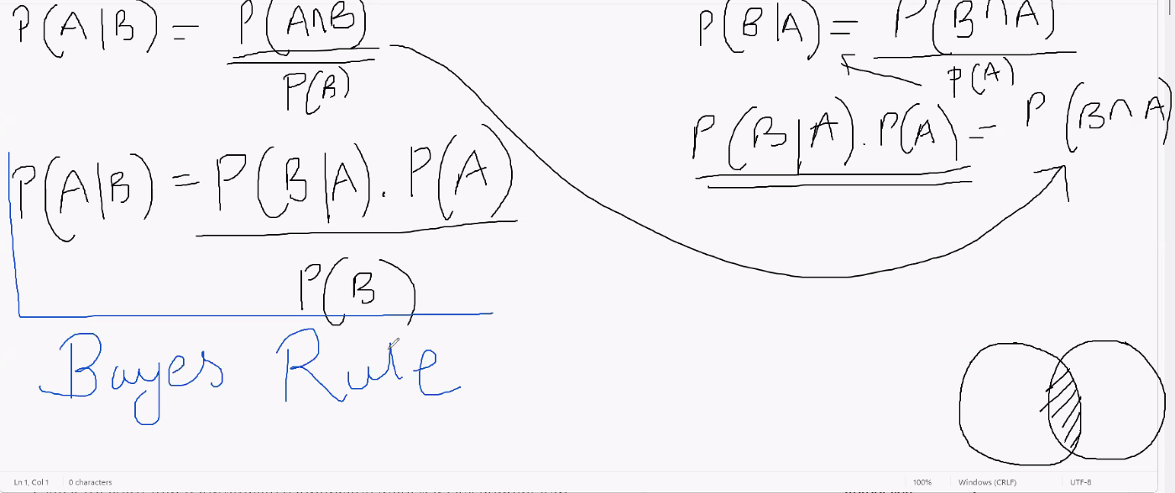

Naïve Bayes.

Scam email Lottery A with the word winner B

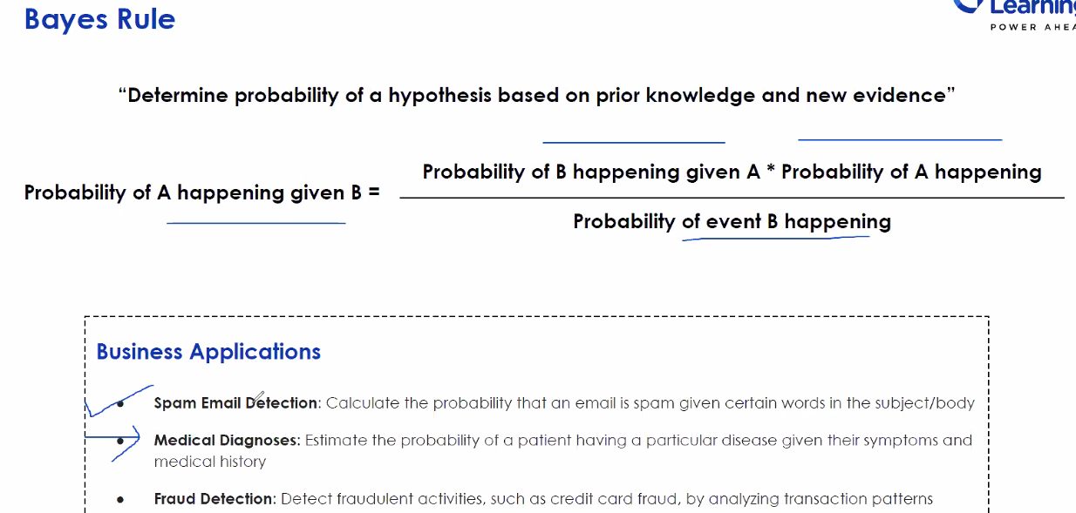

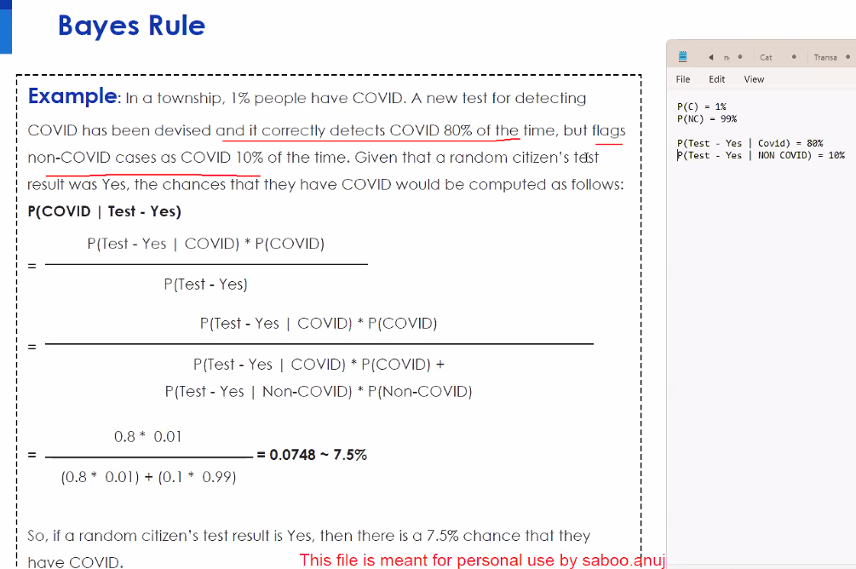

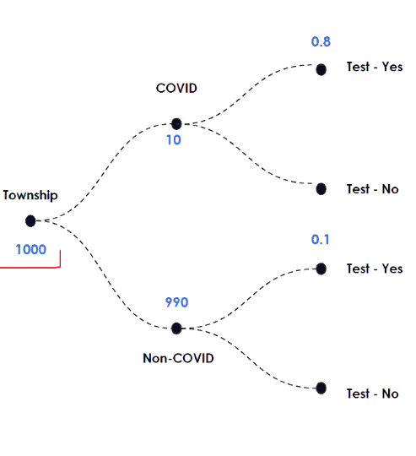

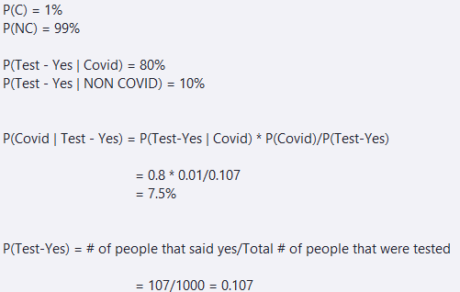

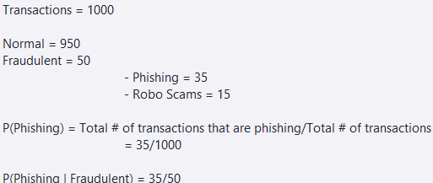

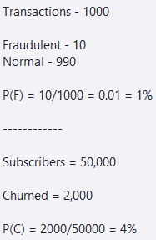

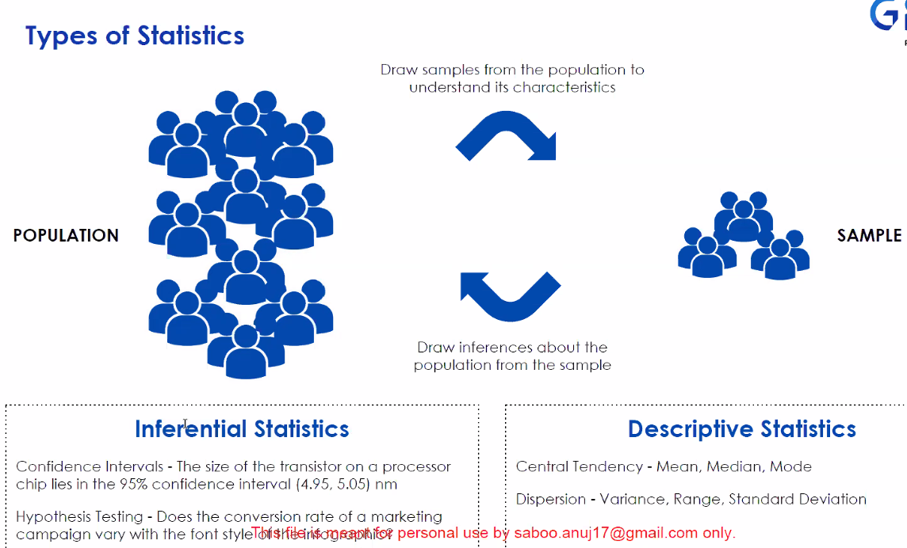

Menu on top of Menu on left – example

More customers are visiting

Success purchases made

Negative result less purchases

Compare the sample v/s population -> Statistical tests

All of this above in Inferential statistics

Describe - Finding average, Range mean, median mode - > Descriptive statistics

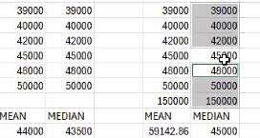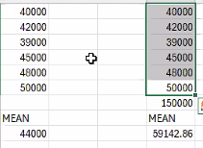

In presence of extreme values , the median is better than mean

Median Sort and find middle number if even (average of middle two)

Percentile : How much is below this point.

Mean – 50th percentile of data.

Mode : Values that repeat most.

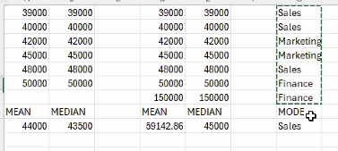

Non numerical data- Mode

Mode Sales

Mode Sales and Marketing

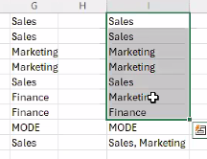

Dispersion – Spread out your data.

Range- Max minus the Minimum – Extent of data.

How are are my individual data points from my mean or median – Variance

Risk in stock :

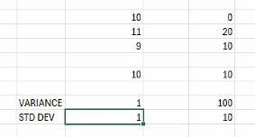

SD less is better less risk Low value close to mean and less risk and less volatile

Normal distribution

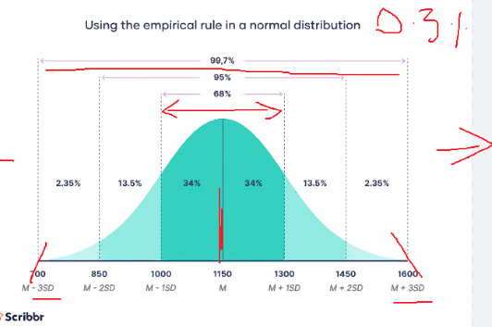

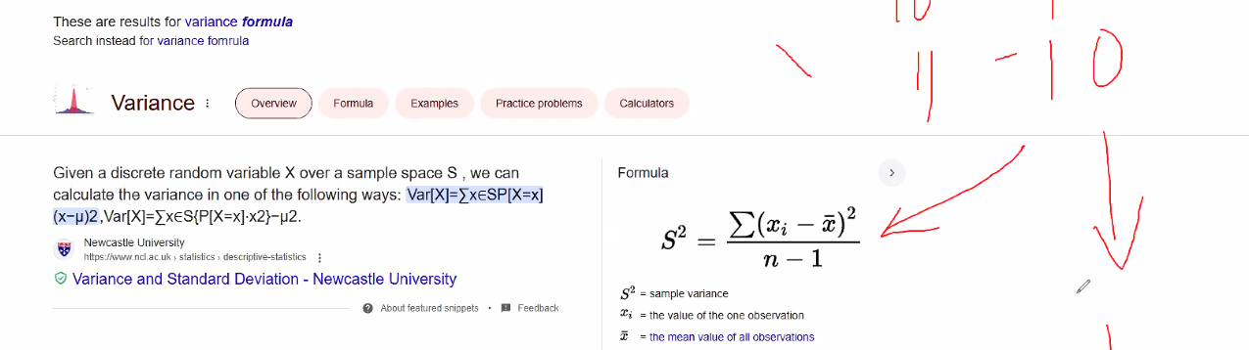

Distribution of Data

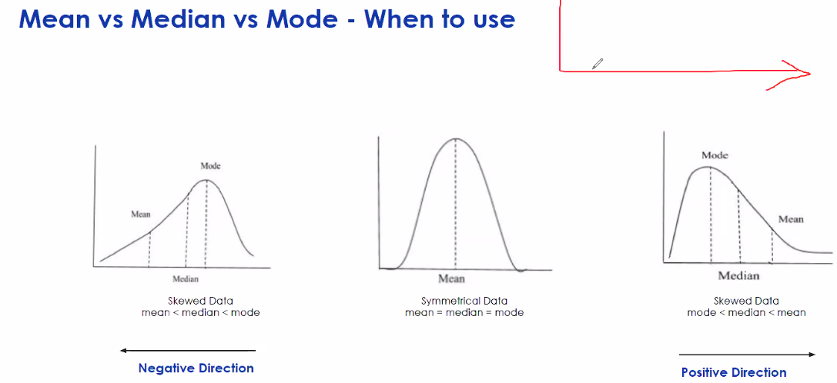Right skewed ( one high salary ) and left skewed (weather /visibility )

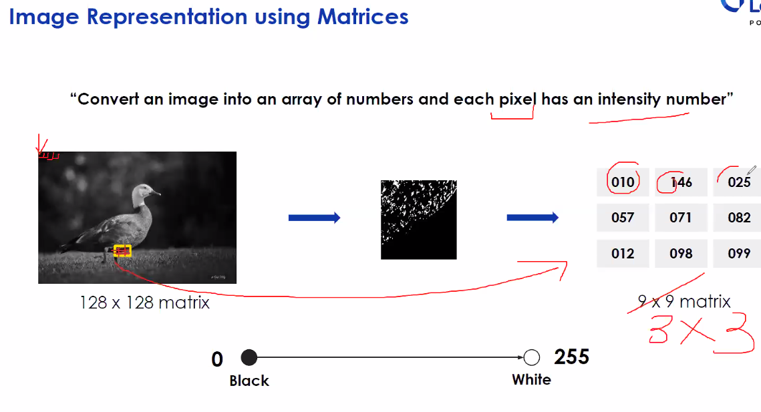

Word encoding – for word to number (Cars example)

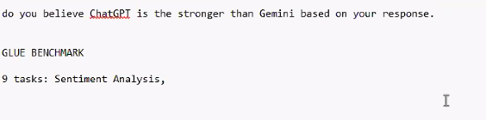

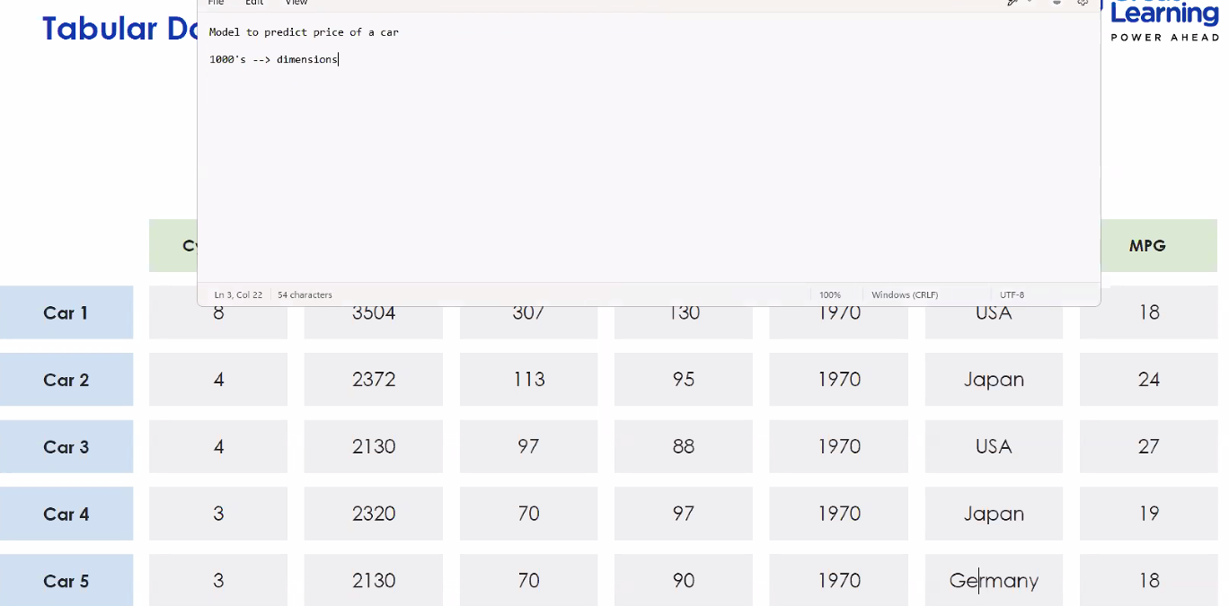

PCA – Principal component analysis Screen plot reduce the data set dimensions.

Data Science: / mathematics

1. Begin with convert a business situation into a question of mathematics &statistics by first representation the data statistically. (scatterplot)
2. Then we take mathematics representation of it thru an equation we estimate the terms in the equation By applying statistics we look at the estimates and then we translate is back to what it means for my business. (slope) sales = a- b*price ( B is the slope)
3. How mathematics and statistics fits in the interpretation of business.

*Taking a Business prob and*

* *representing the data mathematically*
* *Understanding the data statistically*
* *Getting estimates from data using mathematics*
* *Translate the data into estimate to and knowledge that data gives you in quantitative forms to a Business application*

Scatterplot

A and b >= 0

Staistics – approximation change / average expected change.

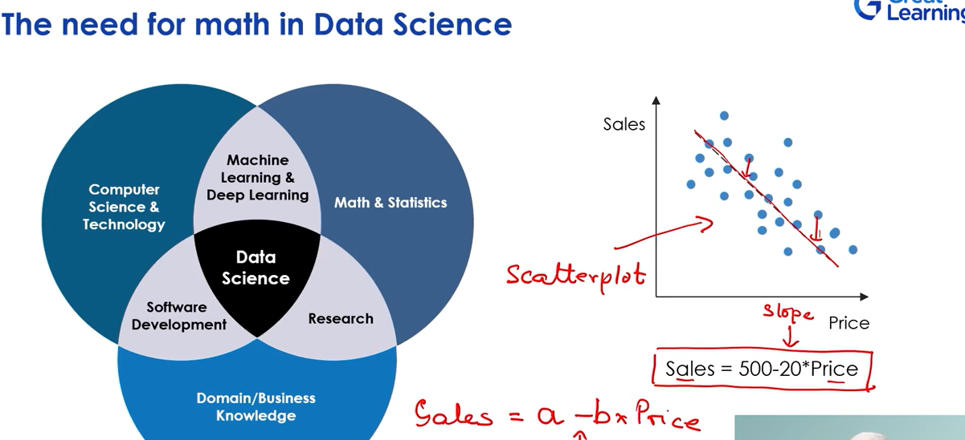

Prob and stats

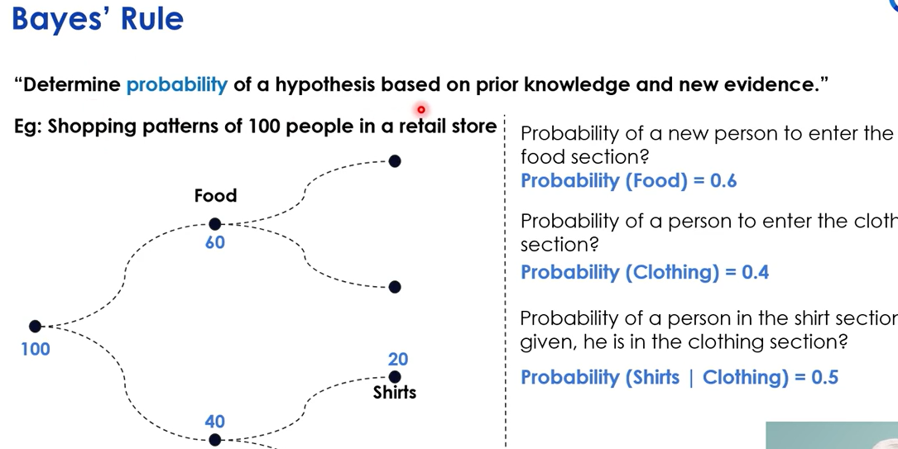

Conditional probability. Conditional statement as given he is in the clothing section.

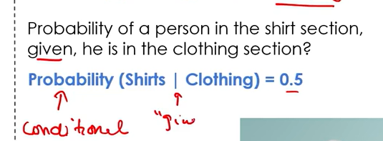

**March 22: Case Study Hotel Booking**

Domain understanding ( industry domain) Inputs, outputs, inherent problem exist

Business context and Problem Definition

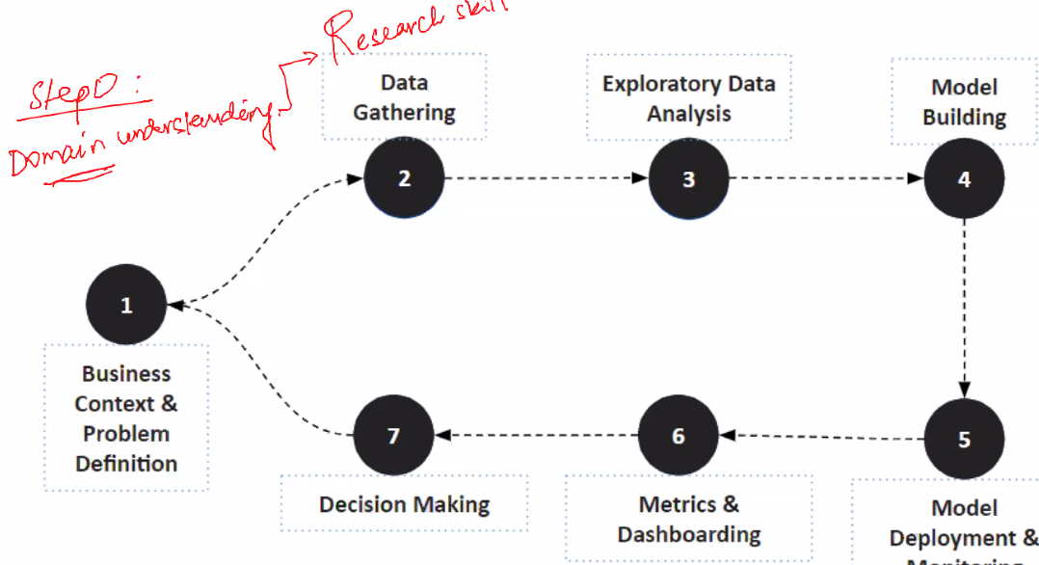

Step 0 : Hypothesis, Ask questions , precise solution

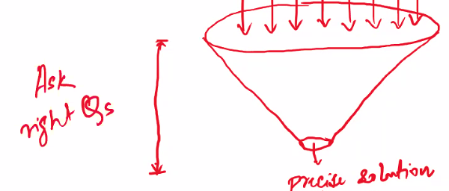

Step 1: Business context / Problem definition

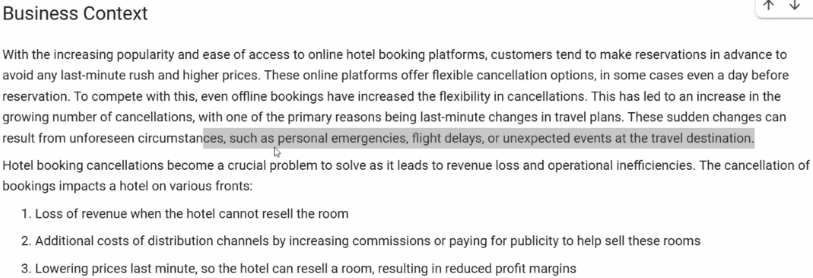

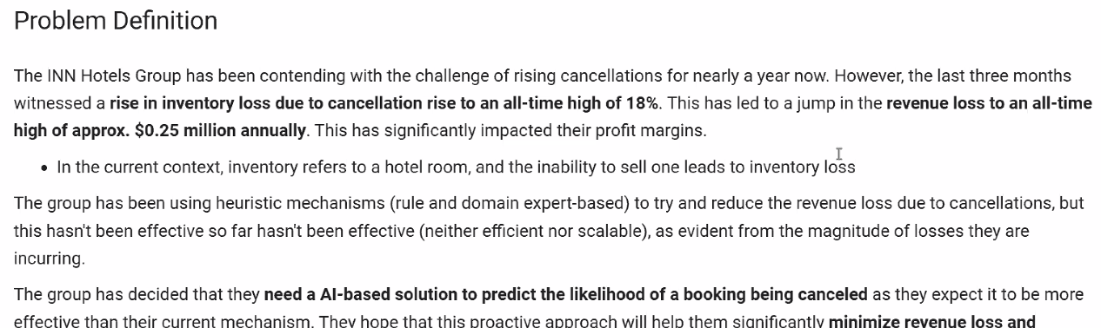

The above is the WHAT and next is How

Data gathering

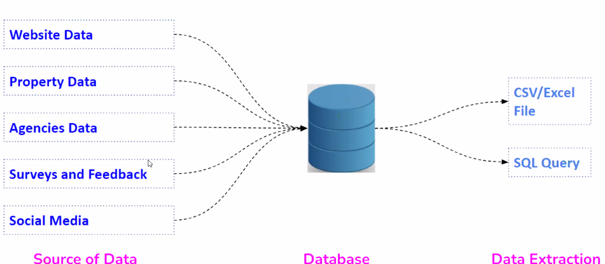

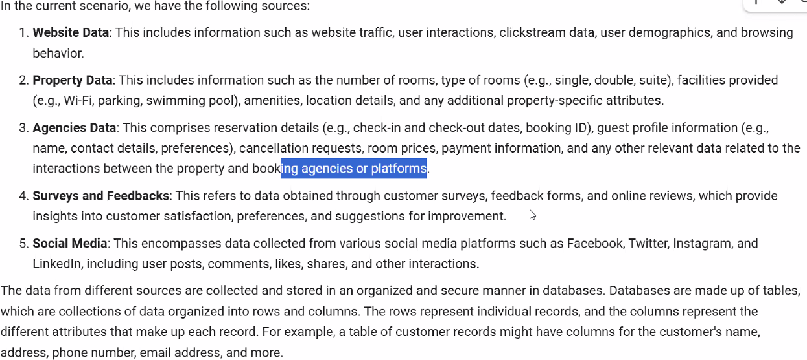

A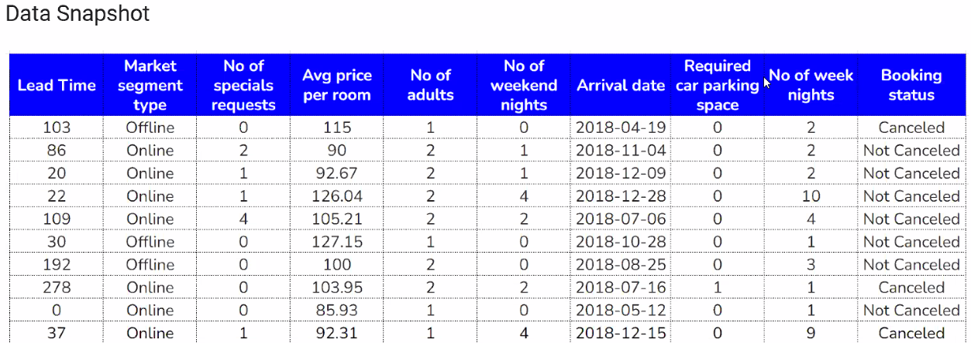

Independent variables - all columns except Booking status (dependent variable)

Y=f(x) (Y is dependent variable and X is independent variable)

**Exploratory Learning: EDA Exploratory Data Analysis**

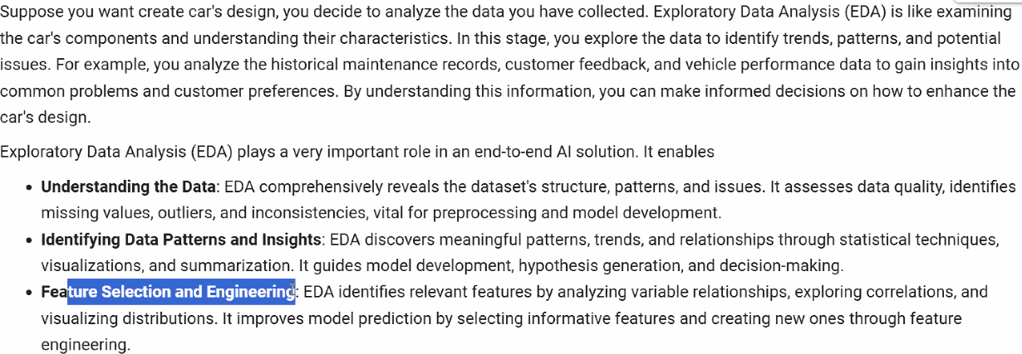

Coming up with a new variable (take out two and replace with 1) reduce complexity – feature Engineering

Dimension Reduction is not dropping variables but combining variables. – Different from Feature engineering.

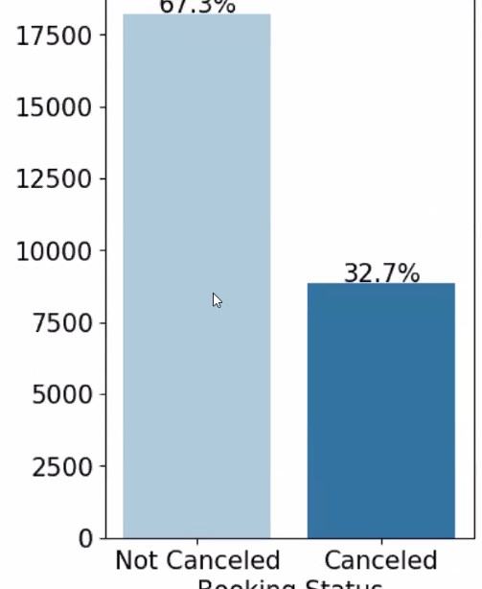

Only 20% of cancelled are rebooked.. Uni variable analysis Booking status/ rebooking.

Bi variable analysis

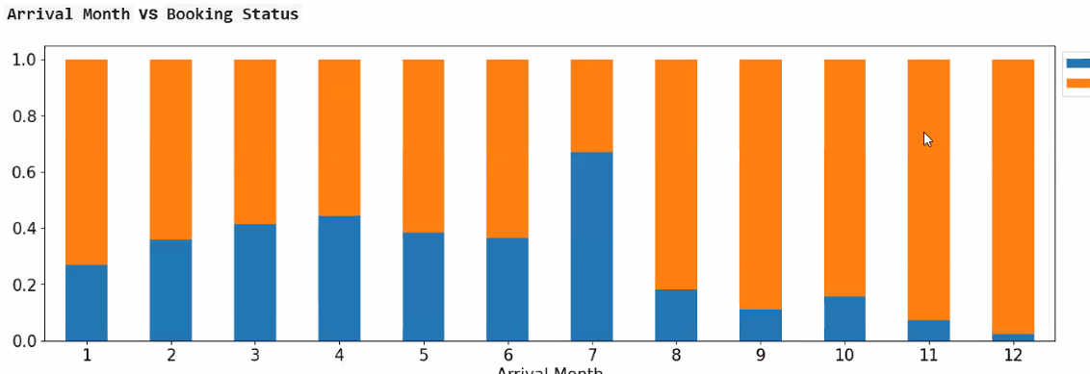

What is missing above is the number of booking.

Box plot. Median is used the line is median ( Early booking getting cancelled)

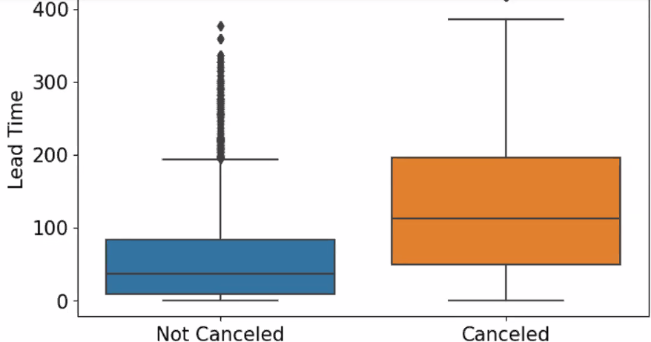

U can 2 or 3 dimensions but we need multi-dimensional, so we need AIML

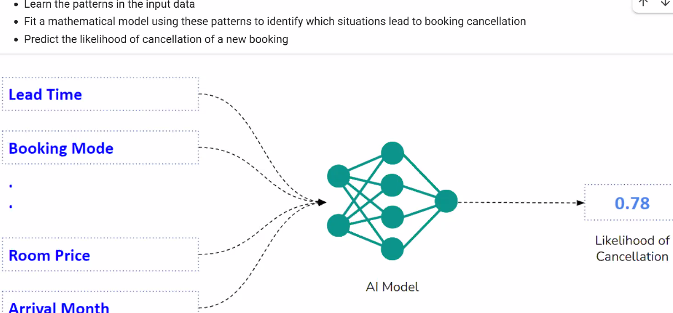

Y=f(x)

how many categories and convert categories to numbers is called Encoding.

Data will need to convert to numbers.

We divide the data, Take dataset and divide test data and trained data.

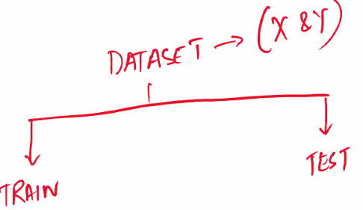

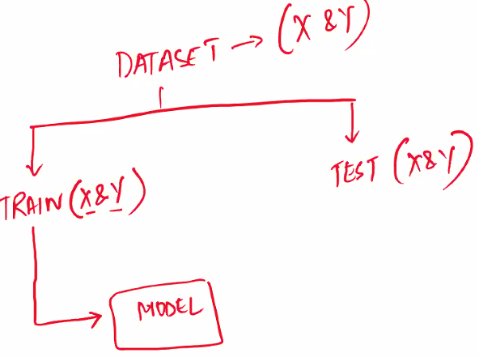

Training Model Learns the intrinsic relationship between x and y

Training is questions and answers ( book example)

We evalute the model with X data to see if it gives Y.

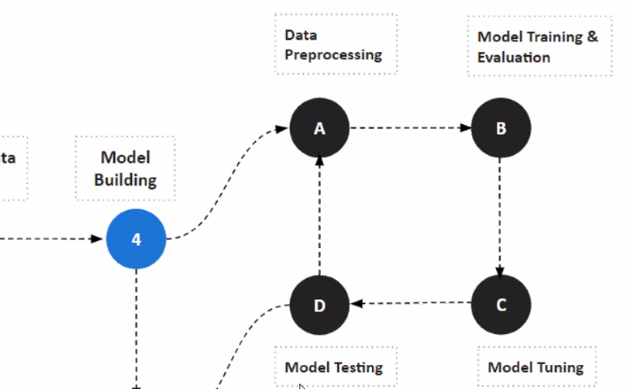

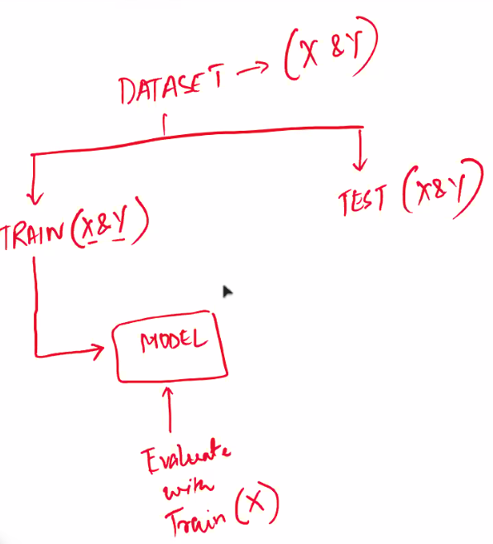

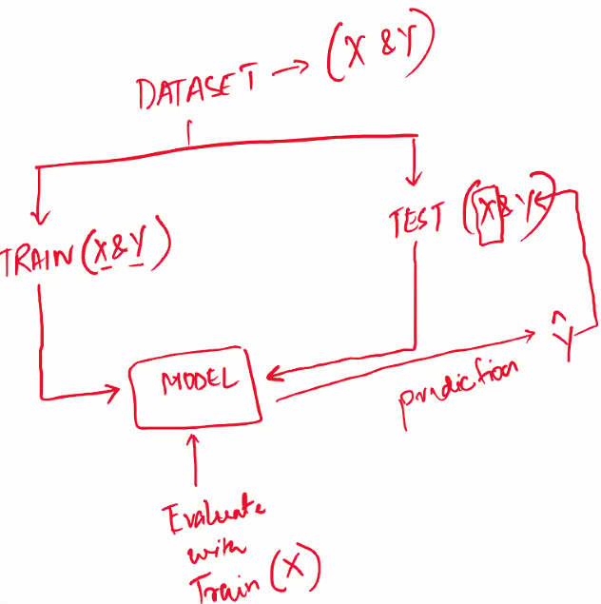

Y Hat is the prediction. Only X is passed.

Use levers are unique to each model are used for Model tuning.

Hyperparameters are inside the model used for tuning. (E.g. RandomForestClassifiers Sklearning.)

We do tuning them we go the Model Testing.

Confusion Matrix

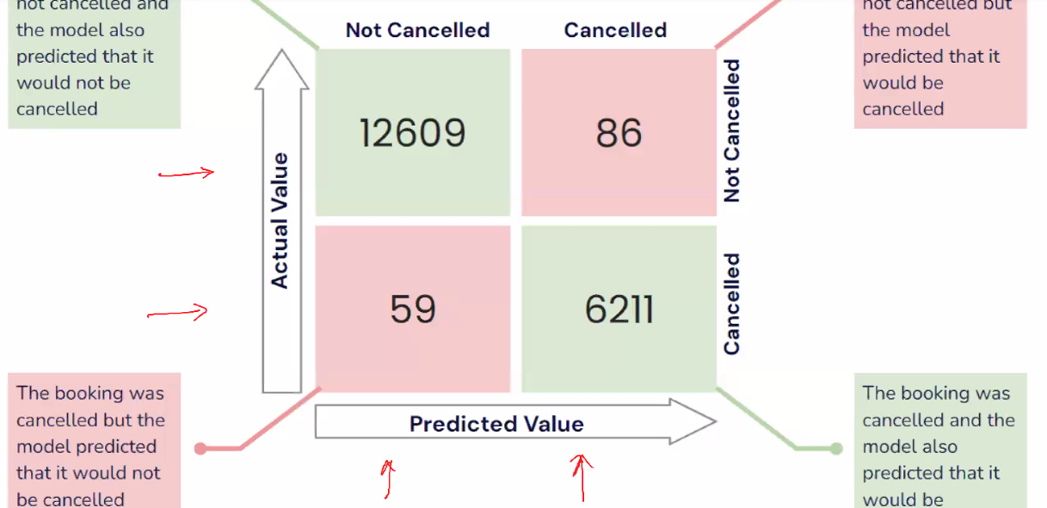

59 – loss to hotels.. rooms not sold or lesser price offers, additional marketing expenses.

86 – Overbooked bad reviews,

Green are matching predictions – no problem models predictions correct.

Pink are problems areas the 59 and 86.

Overfilling: Trained data gives 93 actual testing gives 83 .. We need to Model tuning.

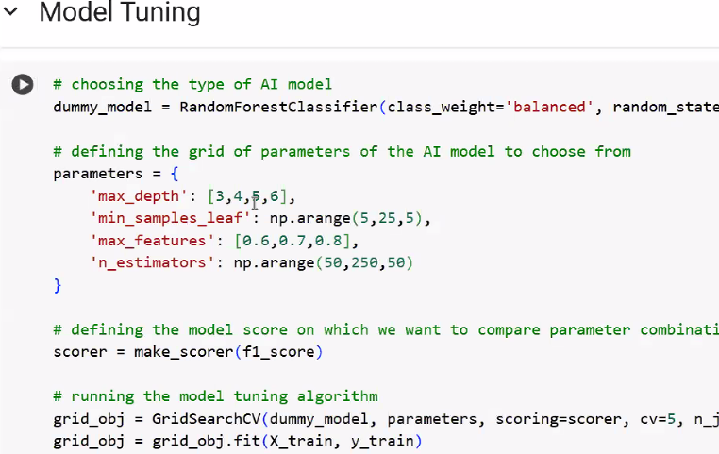

Model deployed

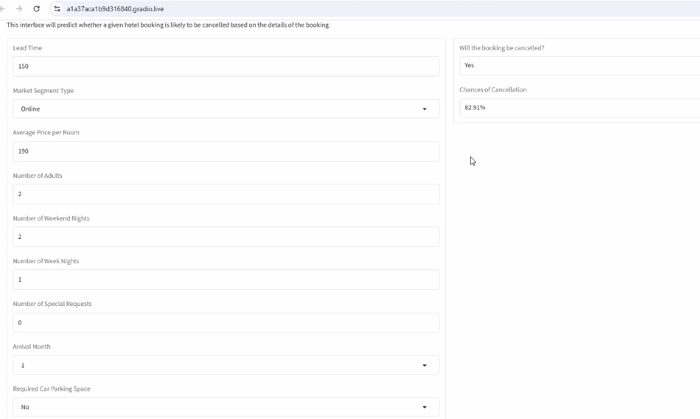

Gives the below 

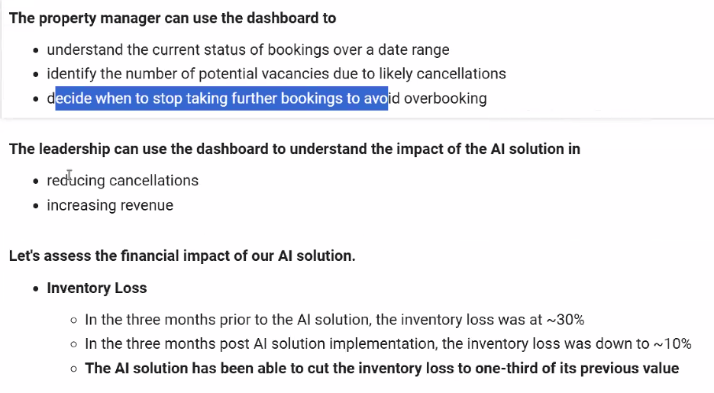

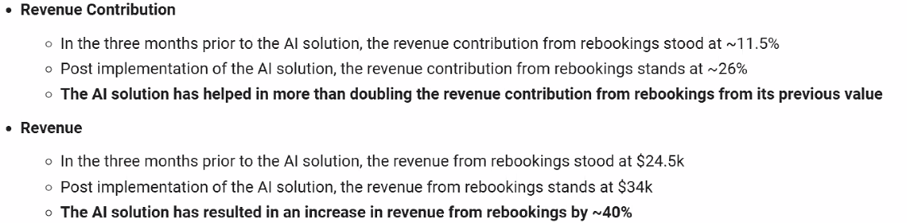

Deep learning

. Feature extraction layer – extraction of feature dog nose ears month, x ray – color borders, etc

Full connected dense layer – Training of models happen, samples, features to labels

Vgg16 and vgg19 designed for image – pretrained models.

[Great Learning](https://olympus.mygreatlearning.com/courses/125476/modules/items/7035462?pb_id=18544) cars notebook

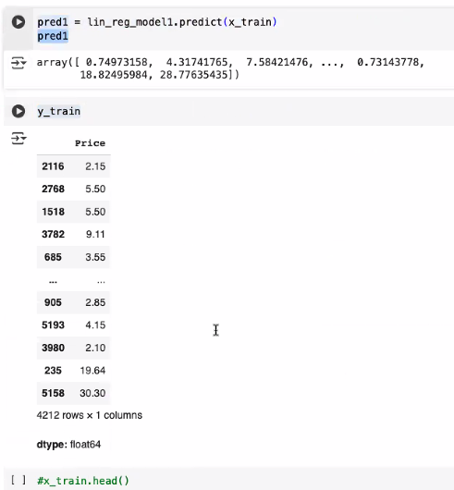

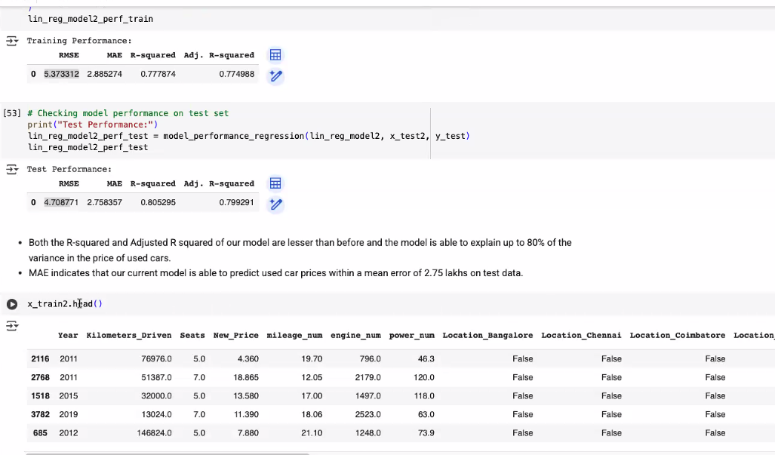

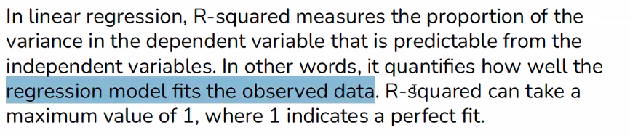

Machine learning 101:

Learning about the world from data

Past is a good representation of the data ( but rain yesterday , rain today, NO so see a past history and pattern )

Amalgamation and two things information and noise .

Information is the data from the past, pattern etc that repeats and needs to be captured

noise is everything around that can influence the data but does not repeat should not capture

noise is unstructured, random and does not repeat itself

Information is strucuted, repeat itself going to repeat but noise will not repeat.

Capture only info and not the noise. Info is the data that repeats.

Under fit and over fit

Underfit model : Not enough information captured

Overfit model : capture the noise along with the information that noise does not repeat itself

Not to overuse the past data and over fit it and also Underuse the past data and underfit it.

Observations from real world is called data. Any form picture, text etc.

Data -🡪 Mathematical model (data science)

1. Take the data



1. Find the patterns
2. Summarize the patterns in a mathematical precise way y=a+x*b
3. Machine learning automates this model building.

Model complexity: try a sequence of models plot a graph between Model complexity and Prediction error.

Prediction error v/s Model complexity :

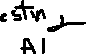

Prediction

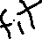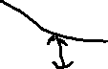

error

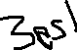

Model Complexity



Relationship between input and output we have a desired output to deduce then Its Supervised

Desired output – in Supervised

Market segmentation , trends, create groups and

No do not have independent

Overfit models does well on training data but poorly on testing data

Underfilt model does well on testing data but poorly on training data

|  |  |
| --- | --- |
| Supervised | Unsupervised |
| Independent variables and dependent var , relationship between them and a desired output Number or text |  |
| Label of the target variable |  |
| Regression – target variable is continuous |  |
| Classification – target variables is category |  |
| House price -Regression,  Person is diabetic based on bp,sugar, etc y/n Classification |  |

Outcome output Response variable, Sales on Y axis

Input, predictor variable , explanatory variable on X axis advertise expense

Positive relationship .. both go up

Product sales and product sales = Negative relationship One up one down.

No relationship Sales v/s Length of product description NO relationship .

Strength of the relationship Strong and Weak

The statistical measure of strength and direction of relationship is called correlation.

Strong and Weak - Strength and Direction positive or negative

Random behavior or randomness is captured by Statistics

Correlations is between -1 and 1.

-1-------------------------------------------------------------------1

0

Negative No Relationship positive

Correlation coefficient (pearson)

Slope coefficient =b1

Intercept coefficient =b0 – Y intercept

Y=b0 + b1x

If b1 is +ve positive correlation if b1 is negative , negative correlation

Slope = A change in Y with a unit increase in X is the slope coefficient

The plot (dot) is the actual and the line is the predicted value.

The line is the predicted data points( model prediction).

Prediction error = Actual value – predicted value

Smaller lines for predictor error is towards best fit.

Aggregate the prediction error gives the least aggregate error is the best fit .

Method of least squares Average of difference between sum of (actual – predictor)2 square

Multiple linear regression

Y= b0 + b1* x1 + b2* x2

Plains 3 dimensional

Dummy variables one hot encoding 0100

**Method of least squares –**

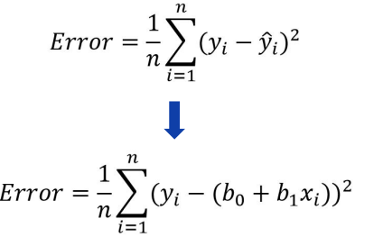

1. **AME** – ABSOULUTE MEAN ERROR

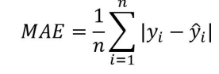

1. **RMSE** – ROOT MEAN SQUARE ERROR penalize large errors. not permit large deviations

(*Because squaring so do a square root)*

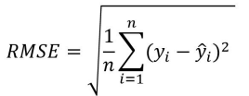

1. **MAPE** Mean absolute percentage error

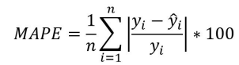

Main difference between **adjusted R-squared** and R-square is,

**R-squared:** Measure of variance dependent variable represented by **every single independent variable .** Values between 0 and 1

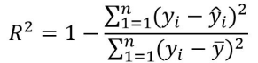

1. **adjusted R-squared :** measures variation explained by **only the independent variables that actually affect the dependent variable**.

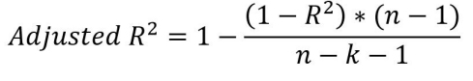

K is the independent variable

| **Metric** | **Value Range** | **Better Value** | **Purpose** | **Other Parameters and Attributes** |
| --- | --- | --- | --- | --- |
| AME (Absolute Mean Error) | (>= 0) | Smaller values are better | Measures the average magnitude of the errors in predictions, without considering their direction. | Simple to interpret, does not penalize larger errors more significantly. |
| RMSE (Root Mean Square Error) | (>= 0) | Smaller values are better | Measures the square root of the average of squared differences between prediction and actual values. | Penalizes larger errors more strongly, providing a good measure for models that need to penalize large deviations. |
| MAPE (Mean Absolute Percentage Error) | 0 to (\infty) | Smaller values are better | Measures the average absolute percentage error between the predicted and actual values. | Percentage-based, so it is easier to interpret in terms of relative error; can be problematic with actual values close to zero. |
| R-squared | 0 to 1 | Closer to 1 is better | Measures the proportion of the variance in the dependent variable that is predictable from the independent variable(s). | Represents goodness-of-fit, but does not account for the number of predictors. |
| Adjusted R-squared | ( -\infty ) to 1 | Closer to 1 is better | Adjusts R-squared for the number of predictors, considering only those that genuinely impact the dependent variable. | Useful for comparing models with different numbers of predictors; penalizes adding non-significant predictors. |

Detailed Explanation:

1. **AME (Absolute Mean Error)**:
   * **Value Range**: (>= 0)
   * **Better Value**: Smaller values indicate better model performance.
   * **Purpose**: Measures the average magnitude of errors without considering their direction. It provides a straightforward measure of model accuracy.
   * **Other Parameters**: Does not heavily penalize larger errors; simple to understand.
2. **RMSE (Root Mean Square Error)**:
   * **Value Range**: (>= 0)
   * **Better Value**: Smaller values indicate better model performance.
   * **Purpose**: Measures the square root of the average of squared differences between predictions and actual observations. This metric gives a more sensitive measure due to squaring, penalizing larger errors strongly.
   * **Other Parameters**: Useful for capturing the effect of larger errors; helps in models where larger errors are particularly undesirable.
3. **MAPE (Mean Absolute Percentage Error)**:
   * **Value Range**: 0 to (\infty)
   * **Better Value**: Smaller values indicate better model performance.
   * **Purpose**: Measures the average absolute percentage error between predicted and actual values, providing a relative measure of accuracy.
   * **Other Parameters**: Sensitive to low actual values, which can result in high percentages; intuitive as a percentage-based metric.
4. **R-squared**:
   * **Value Range**: 0 to 1 (can be negative for poor models but typically interpreted within 0-1)
   * **Better Value**: Values closer to 1 indicate better model performance.
   * **Purpose**: Measures the proportion of variance in the dependent variable accounted for by the independent variable(s), indicating the explanatory power of the model.
   * **Other Parameters**: Does not adjust for the number of predictors; can give a misleading sense of performance with too many predictors.
5. **Adjusted R-squared**:
   * **Value Range**: ( -\infty ) to 1 (typically positive and close to R-squared)
   * **Better Value**: Values closer to 1 indicate better model performance.
   * **Purpose**: Provides a refined measure of the variance explained, adjusting for the number of predictors in the model.
   * **Other Parameters**: Penalizes adding predictors that do not improve the model significantly, making it a more reliable measure for comparing models with different predictors.

This table encapsulates the core details of each metric, assist



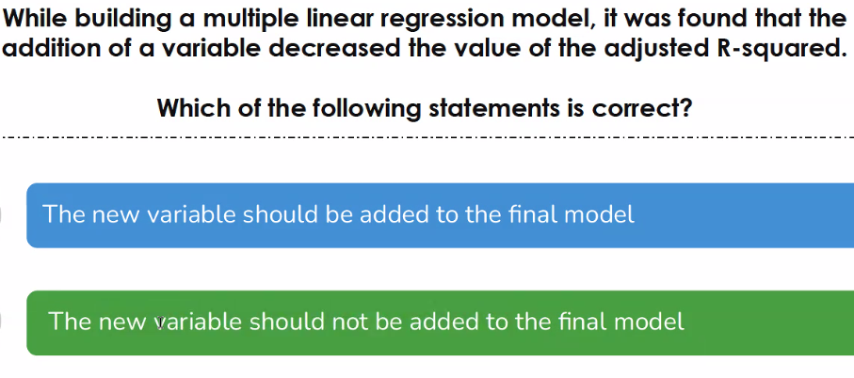

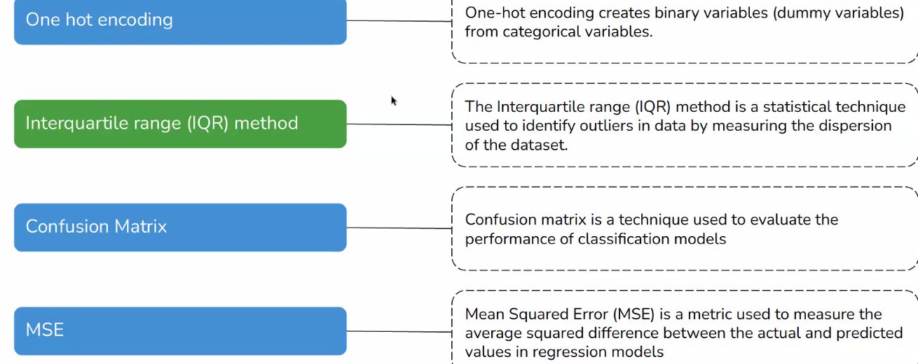

<https://scikit-learn.org/stable/modules/generated/sklearn.tree.DecisionTreeClassifier.html>

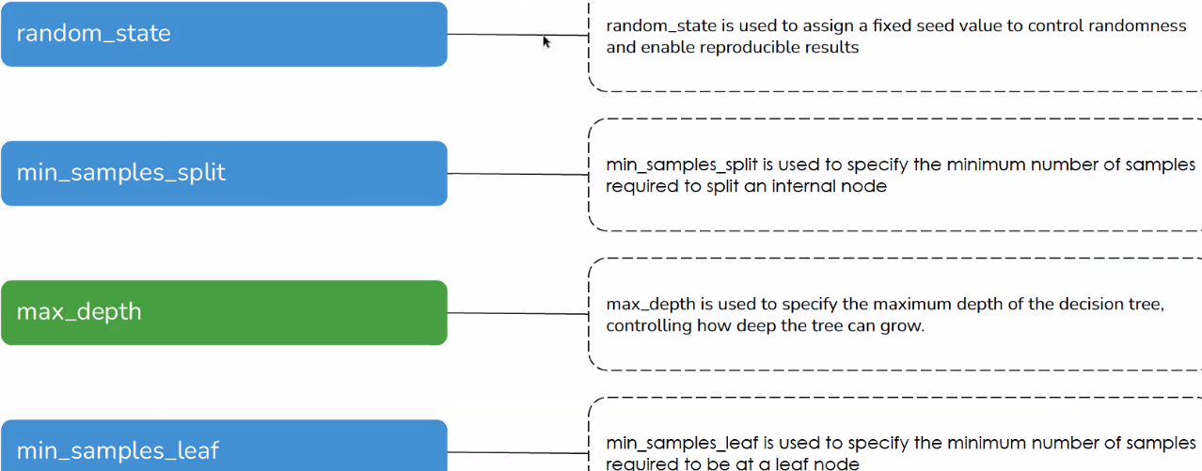

**Decisions Tree**

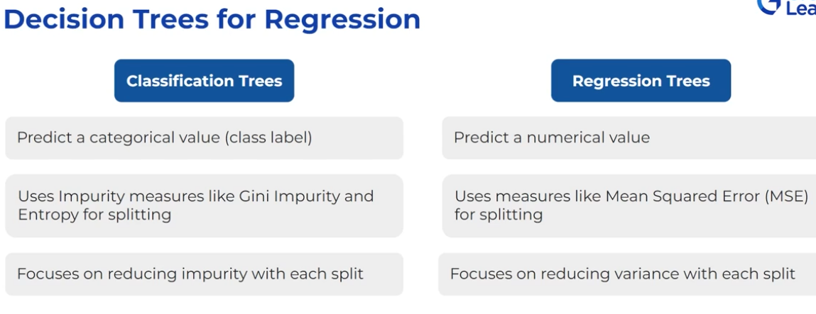

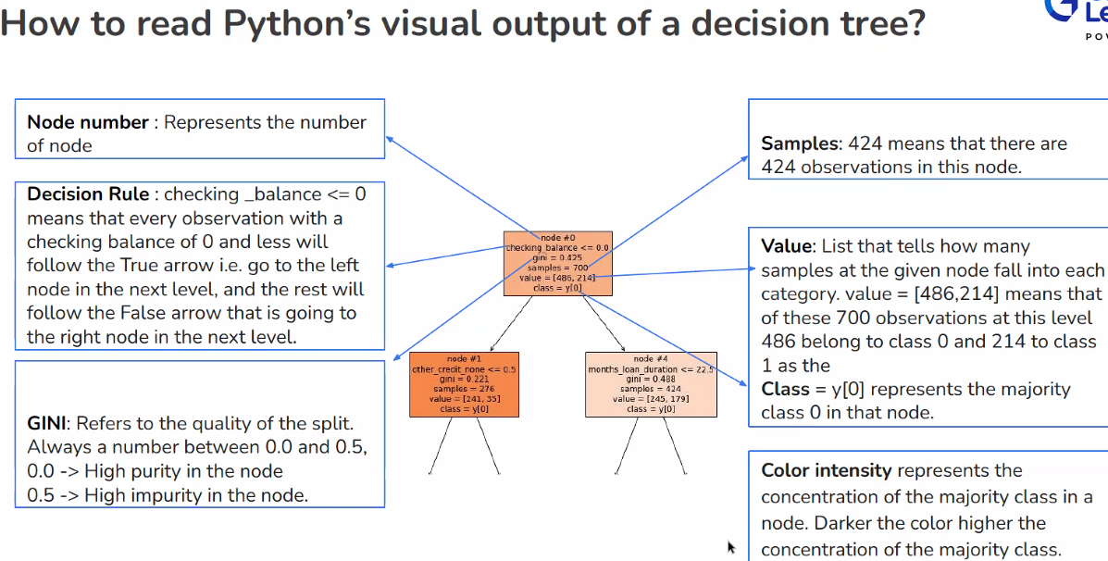

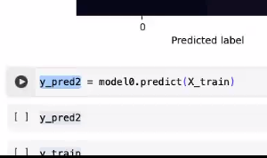

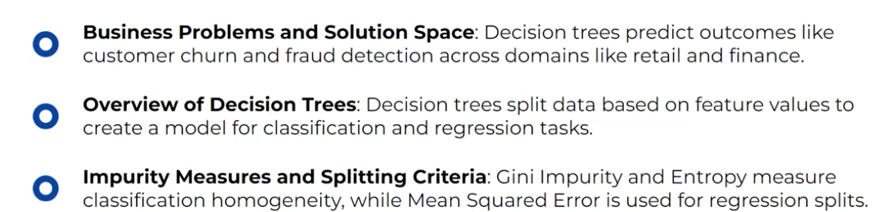

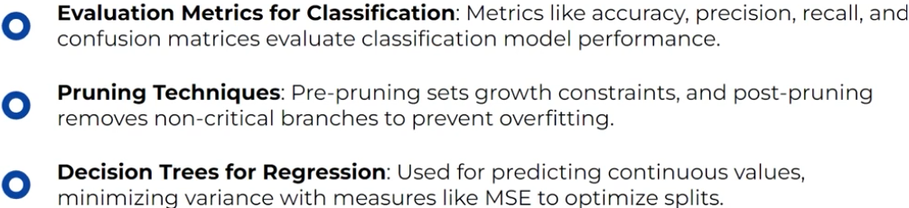

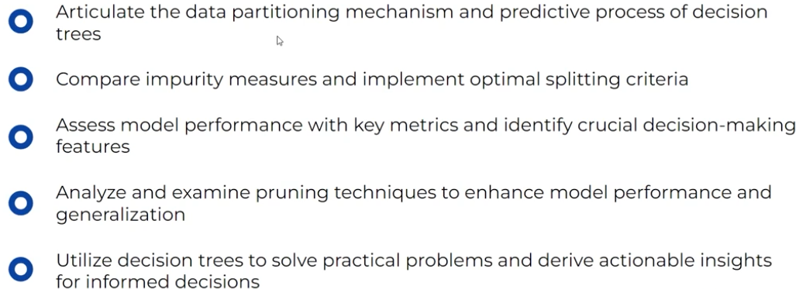

In the context of decision trees, the selection of the right tree among several options typically involves evaluating their performance on both training and test datasets, as well as considering the model’s ability to generalize to unseen data.

Here’s how you might assess the right decision tree:

1.**Training Performance**: Initially, you may look at how well each decision tree performs on the training data. An overfit tree might show perfect accuracy or very high scores on the training data, but this is not a good indicator of a model’s overall effectiveness.

2. **Test Performance**: More importantly, evaluate the trees based on their performance metrics on the test set. Metrics to consider include accuracy, precision, recall, and F1 score, as these provide insight into how well the tree generalizes beyond the training data.

3.**Generalization**: The key criteria is how well the decision tree generalizes to new, unseen data. A balanced performance on test data without substantial drops in accuracy typically indicates good generalization. Pruned trees (either pre-pruned or post-pruned) often offer better generalization by reducing complexity.

4.**Complexity vs. Interpretability**: Another consideration is the trade-off between the complexity of the tree and its interpretability. A simpler, pruned tree will generally be more interpretable, making it easier to understand and explain the model’s predictions.

5.**Overfitting Mitigation**: Pruning strategies (both pre-pruning and post-pruning) are used to mitigate overfitting. The right decision tree would be one that is pruned to a level where it retains significant accuracy while avoiding the pitfalls of overfitting.

In summary, the right decision tree is often one that balances performance with simplicity, generalizing well to new data and avoiding overfitting through effective use of pruning strategies.

Decision Tree:

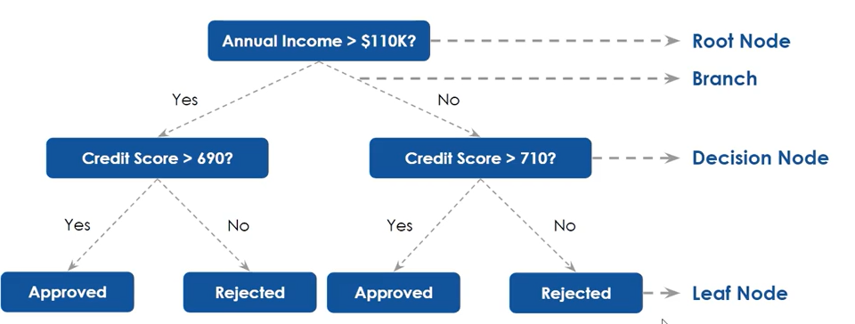

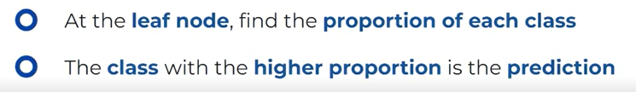

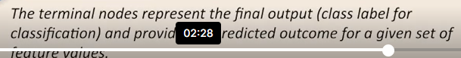

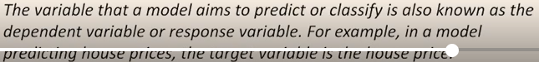

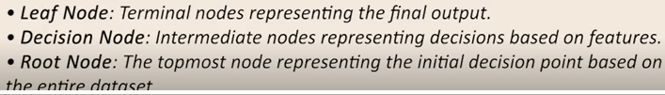

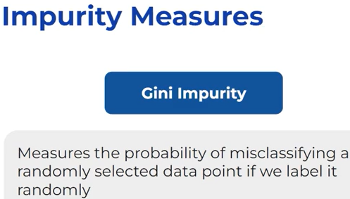

Example : income distribution

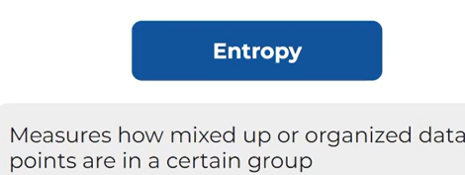

Example: Molecules are mixed in a certain compound



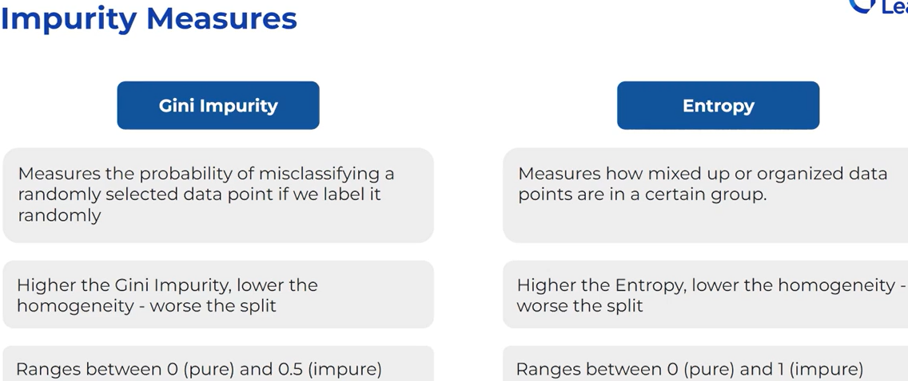

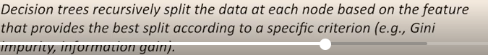

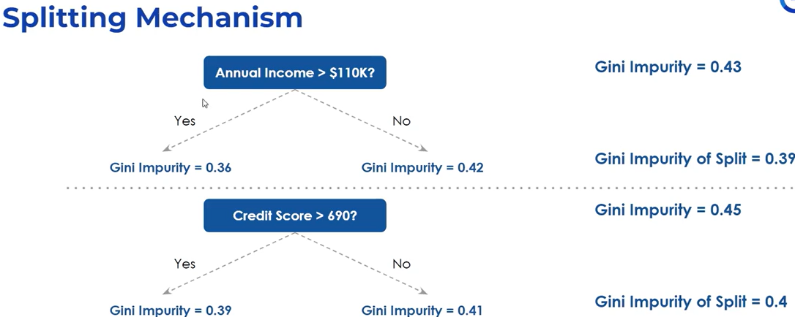



Closer to zero less on the (leaf closer to zero) is to be taken Annual income here.

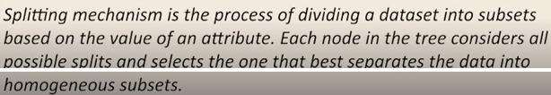

AT what point to split 110 or 70. Compare the Gini impurity at the left

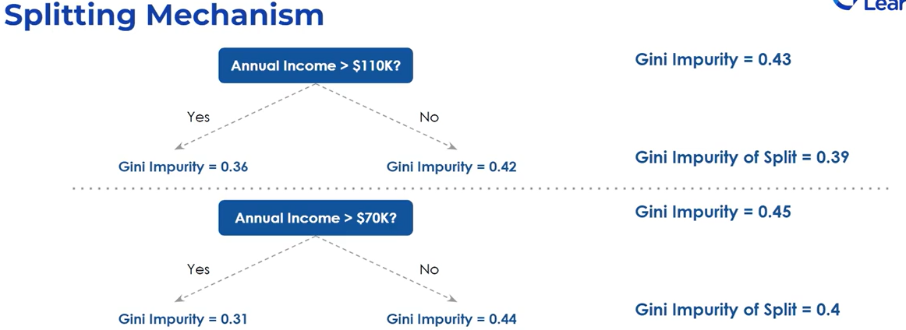

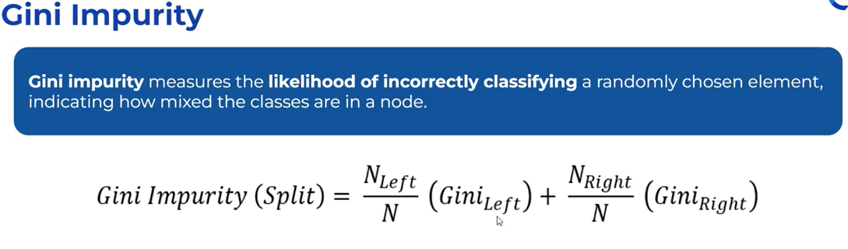

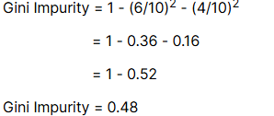

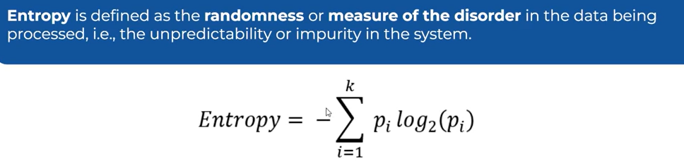

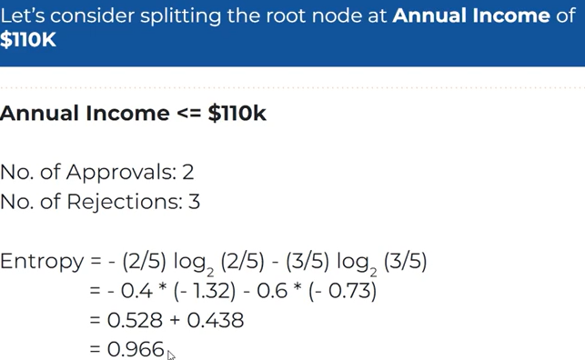

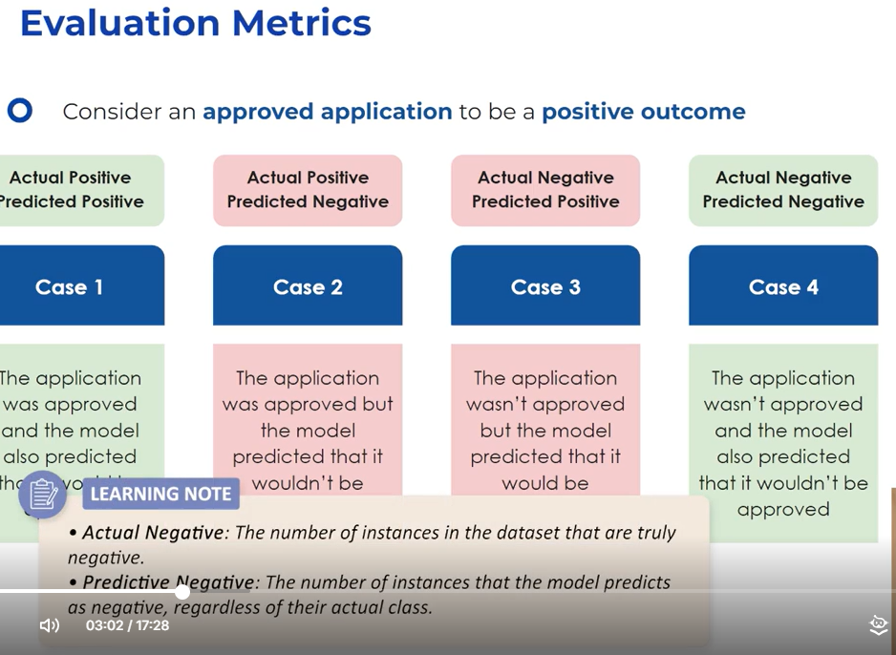

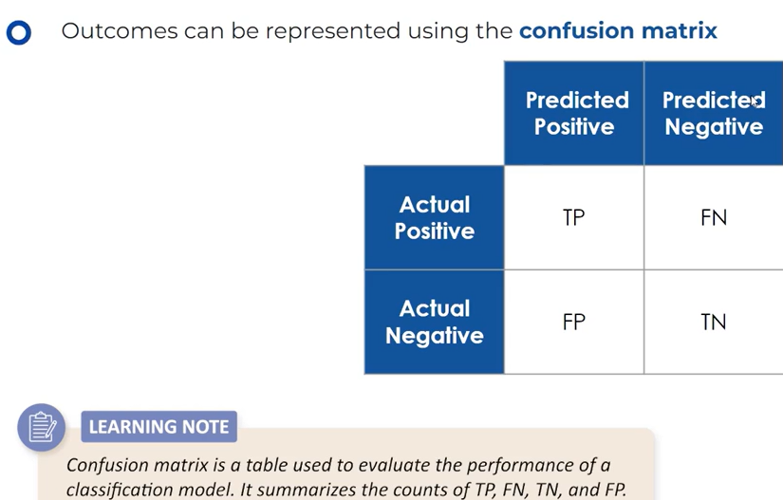

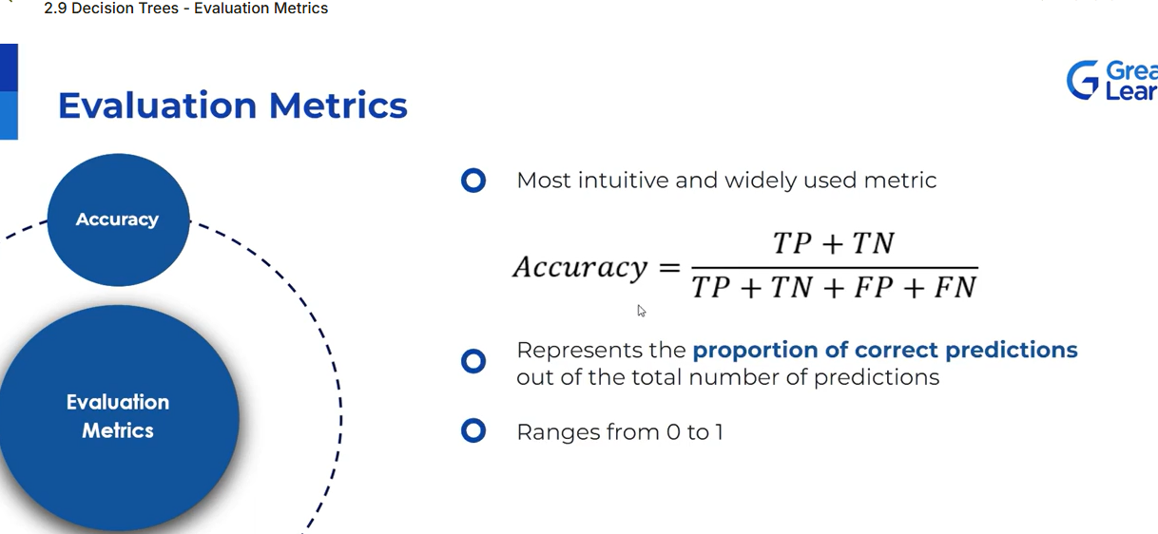

<https://cohere.com/blog/classification-eval-metrics?utm_source=google&utm_medium=cpc&utm_campaign=fy25_amer_1_awareness_paidsearch_22285080165_179273636361_737093627743&utm_term=%7Bquerystring%7D&gad_source=1&gad_campaignid=22285080165&gbraid=0AAAAA-uE0d80gAyWH6EGC406JQrk4R-S3&gclid=Cj0KCQjw0erBBhDTARIsAKO8iqTbgrxObB7CRo0CU6rv7MnUqSLE4hGqihaJmX7jEu5n_qreLNabExAaAtLlEALw_wcB>

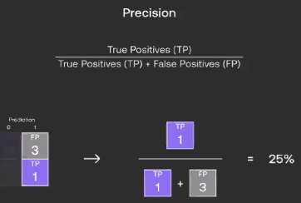

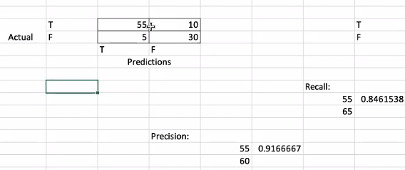

Clustering

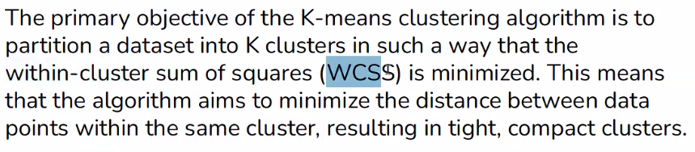

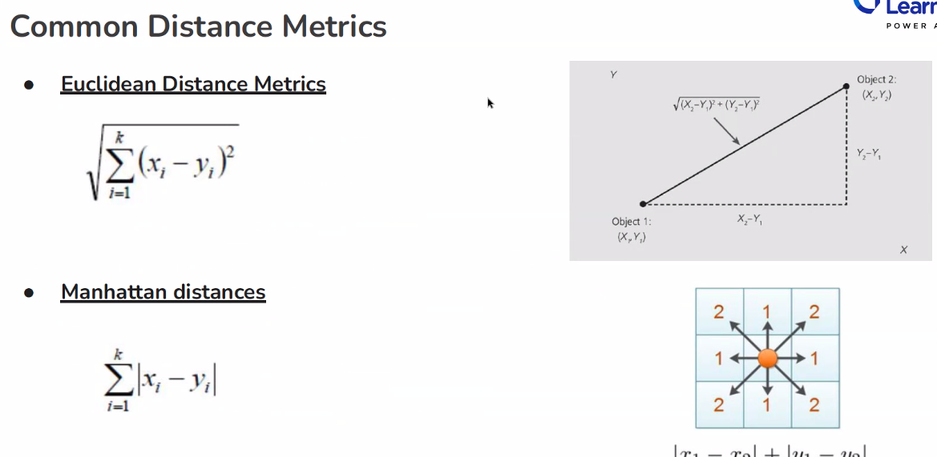

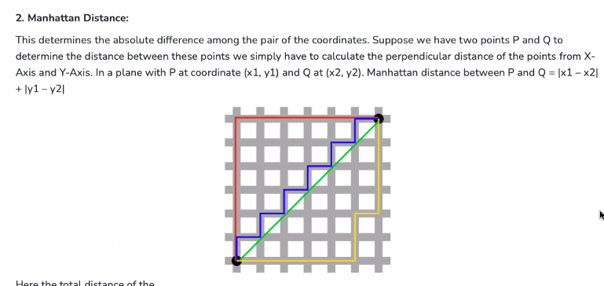

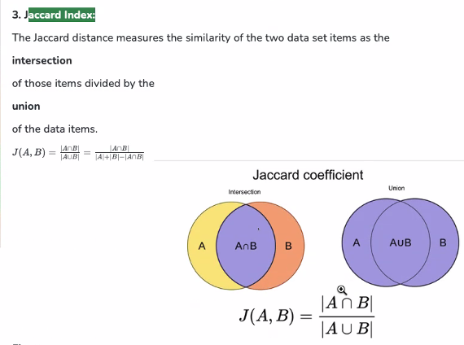

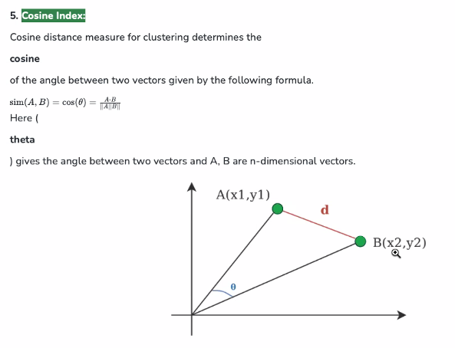

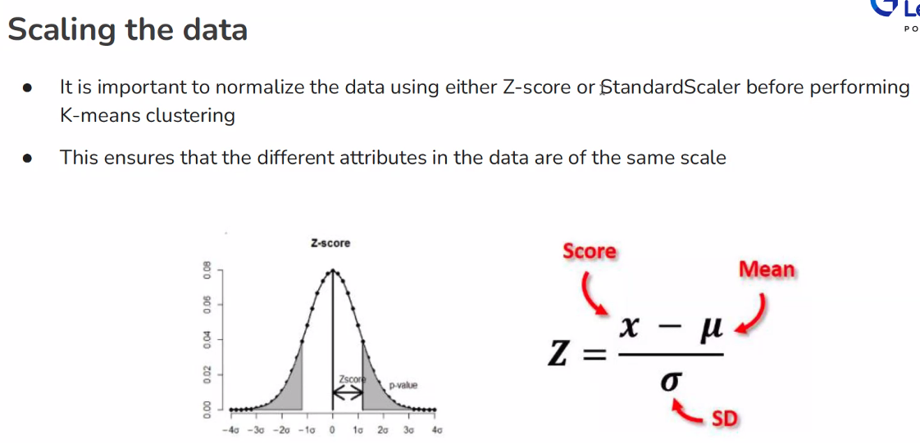

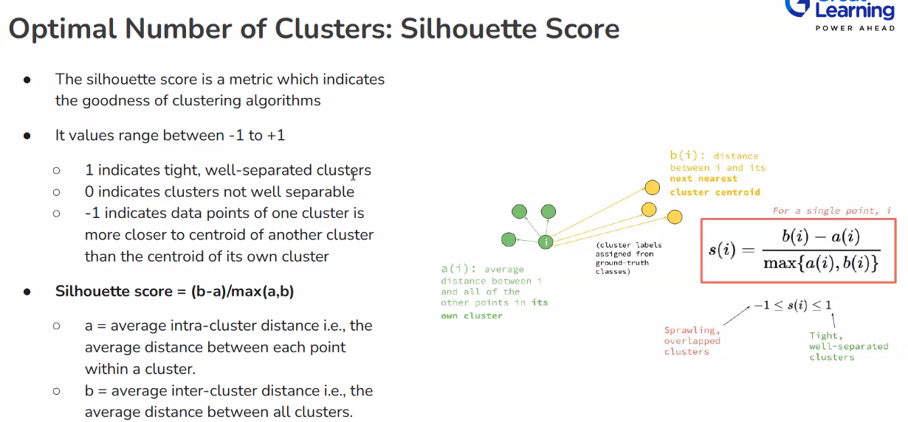

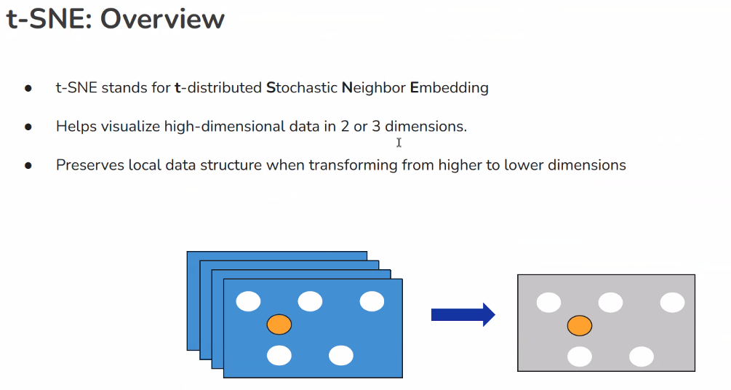

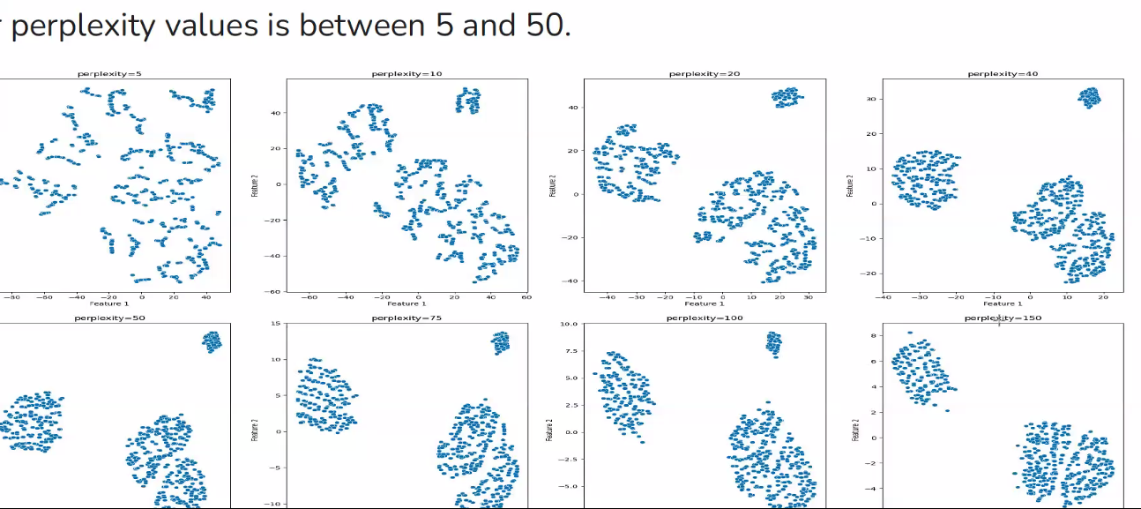

**Projects AllLife Bank**

[**https://htmtopdf.herokuapp.com/ipynbviewer/**](https://htmtopdf.herokuapp.com/ipynbviewer/)

**have a notebook for converting my work notebook to HTML.  It has this code:  
  
Anthony Aguilar . 11:46 AM  
from google.colab import drive  
drive.mount('/content/drive')  
  
!jupyter nbconvert /content/drive/MyDrive/X**

**Recall metrics for model performance**

6/28 notebook

##example, using OneHotEncoder:  
encoder = OneHotEncoder(handle_unknown='ignore', sparse=False)  
X_train_encoded = encoder.fit_transform(X_train_categorical)  
X_val_encoded = encoder.transform(X_val_categorical)  
X_test_encoded = encoder.transform(X_test_categorical)